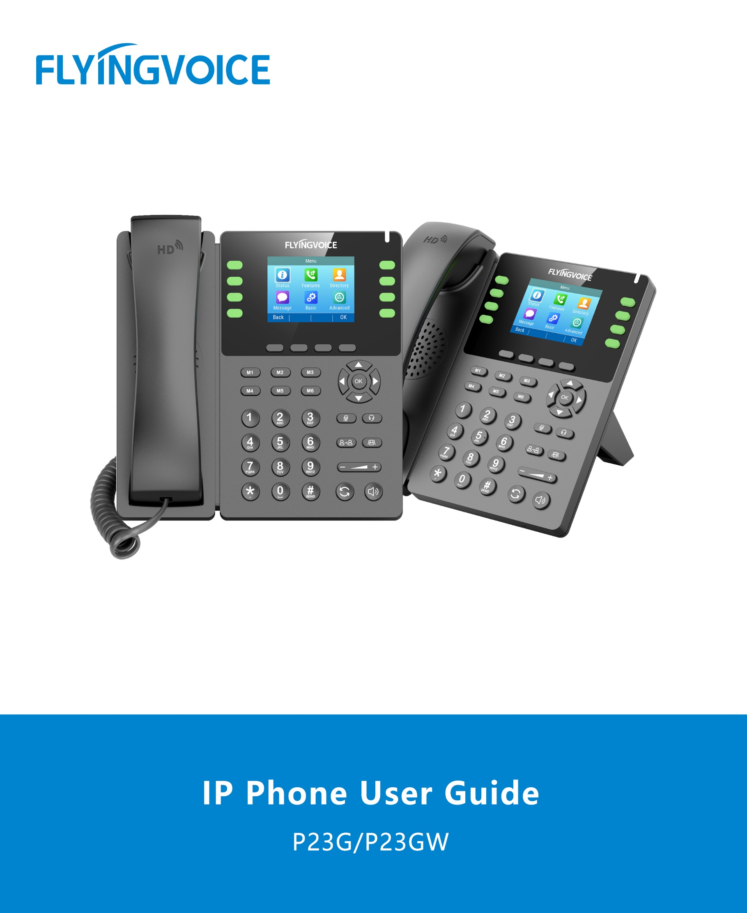

**Version 1.4.0**

**Jul. 2025**

**Copyright**

Copyright © 2020 Flyingvoice Network Technology CO., LTD.

Copyright © 2020 Flyingvoice Network Technology CO., LTD. All rights reserved. No parts of this publication may be reproduced or transmitted in any form or by any means, electronic or mechanical, photocopying, recording, or otherwise, for any purpose, without the express written permission of Flyingvoice Network Technology CO., LTD. Under the law, reproducing includes translating into another language or format.

When this publication is made available on media, Flyingvoice Network Technology CO., LTD. gives its consent to downloading and printing copies of the content provided in this file only for private use but not for redistribution. No parts of this publication may be subject to alteration, modification or commercial use. Flyingvoice Network Technology CO., LTD. will not be liable for any damages arising from use of an illegally modified or altered publication.

**Trademark**

Flyingvoice®, the logo and the name and marks are trademark of Flyingvoice Network Technology CO., LTD, which are registered legally in China, the United States, EU (European Union) and other countries.

All other trademarks belong to their respective owners. Without Flyingvoice’s express written permission, the recipient shall not reproduce or transmit any portion thereof in any form or by any means, with any purpose other than personal use.

**Warranty**

**1. Warranty**

THE SPECIFICATIONS AND INFORMATION REGARDING THE PRODUCTS IN THIS GUIDE ARE SUBJECT TO CHANGE WITHOUT NOTICE. ALL STATEMENTS, INFORMATION, AND RECOMMENDATIONS IN THIS GUIDE ARE BELIEVED TO BE ACCURATE AND PRESENTED WITHOUT WARRANTY OF ANY KIND, EXPRESS OR IMPLIED. USERS MUST TAKE FULL RESPONSIBILITY FOR THEIR APPLICATION OF PRODUCTS.

**2. Disclaimer**

FLYINGVOICE NETWORK TECHNOLOGY CO., LTD. MAKES NO WARRANTY OF ANY KIND WITH REGARD TO THIS GUIDE, INCLUDING, BUT NOT LIMITED TO, THE IMPLIED WARRANTIES OF MERCHANTABILITY AND FITNESS FOR A

PARTICULAR PURPOSE. FLYINGVOICE Network Technology CO., LTD. shall not be liable for errors contained herein nor for incidental or consequential damages in connection with the furnishing, performance, or use of this guide.

**3. Limitation of Liability**

Flyingvoice and/or its respective suppliers are not responsible for the suitability of the information contained in this document for any reason. The information is provided “as is”, and Flyingvoice does not provide any warranty and is subject to change without notice. All risks other than risks caused by use of the information are borne by the recipient. In no event, even if Flyingvoice has been suggested the occurrence of damages that are direct, consequential, incidental, special, punitive or whatsoever (Including but not limited to loss of business profit, business interruption or loss of business information), shall not be liable for these damages.

**End User License Agreement**

This End User License Agreement ("EULA") is a legal agreement between you and Flyingvoice. By installing, copying or otherwise using the Products, you: (1) agree to be bounded by the terms of this EULA, (2) you are the owner or an authorized user of the device, and (3) you represent and warrant that you have the right, authority and capacity to enter into this agreement and to abide by all its terms and conditions, just as if you had signed it. The EULA for this product is available on the Flyingvoice Support page for the product.

**Patent Information**

China, the United States, EU (European Union) and other countries are protecting one or more patents of accompanying products and/or patents being applied by Flyingvoice.

**Technical Support**

Visit www.flyingvoice.com for product documents and FAQ, or contact Flyingvoice by email at support@flyingvoice.com. We’ll get you the help you need.

**Declaration of Conformity**

**Part 15 FCC Rules**

**FCC STATEMENT:**

This device complies with Part 15 of the FCC Rules. Operation is subject to the following three conditions:

• This device may not cause harmful interference

• This device must accept any interference received, including interference that may cause undesired operation.

**Warning:** Changes or modifications not expressly approved by the party responsible for

compliance could void the user's authority to operate the equipment.

NOTE: This equipment has been tested and found to comply with the limits of a Class B digital device, pursuant to Part 15 of the FCC Rules. These limits are designed to provide reasonable protection against harmful interference in a residential installation. This equipment generates, uses and can radiate radio frequency energy, and if not installed and used in accordance with the instructions, may cause harmful interference to radio or television reception, which can be determined by turning the equipment off and on, the user is encouraged to try to correct the interference by one or more of the following measures:

-- Reorient or relocate the receiving antenna.

-- Increase the separation between the equipment and receiver.

-- Connect the equipment into an outlet on a circuit different from that to which the receiver is connected.

-- Consult the dealer or an experienced radio/TV technician for help.

**FCC Radiation Exposure Statement:**

This equipment complies with FCC radiation exposure limits set forth for an uncontrolled environment. This equipment should be installed and operated with minimum distance 20cm between the radiator & your body.

**CE**

Manufacturer: Flyingvoice Network Technology Co., Ltd.

Address: 1801-1802, Building 1, Chongwen Park, Nanshan Zhiyuan, Nanshan District, Shenzhen, China

Hereby, Flyingvoice Network Technology Co., Ltd. declares that this device is in compliance with the essential requirements and other relevant provisions of Directive 2014/53/EU.

A copy of the declaration of conformity can be obtained with this user manual; this product is not restricted in the EU.

The full text of the EU declaration of conformity (DoC) is available at following internet address: <https://flyingvoice.com/download.html>

The wireless operation frequency

WIFI: 2412MHz-2472MHz, Max EIRP Power 18.16 dBm

**Safety warning and Attentions**

If use adapter, adapter must be comply 2014/30/EU Directive.

Adapter Caution: Adapter shall be installed near the equipment and shall be easily accessible.

Do not store or use your product in temperatures higher than 50ºC.

**RF Exposure Statement**

The distance between user and products should be no less than 20cm.

=

**GNU GPL INFORMATION**

Flyingvoice phone firmware contains third-party software under the GNU General Public License (GPL). Flyingvoice uses software under the specific terms of the GPL. Please refer to the GPL for the exact terms and conditions of the license.

The original GPL license, source code of components licensed under GPL and used in Flyingvoice products can be downloaded online:

<https://www.flyingvoice.com/soft_GPL.aspx>

**Risk Warning Statement**

This risk warning statement contains a summary of external network servers that FVUI will access under its factory settings in order to obtain necessary service support. If you want to prohibit these accesses based on security considerations, you can disable them through the WEB management page.

|  |  |  |  |
| --- | --- | --- | --- |
| **Number** | **Server Domain Name** | **Description** | **Factory Setting** |
| **1** | <https://rps.flyingvoice.net>/frps | Flyingvoice Provision redirect server | Enable |
| **2** | pool.ntp.org/cn.pool.ntp.org | NTP server | Enable |
| **3** | https://prv3.flyingvoice.net:446 | Flyingvoice Provision web management configuration server | Enable |
| **4** | https://prv4.flyingvoice.net:446 | Flyingvoice Provision web management backup server | Enable |

**Table of Contents**

About This Guide 6

Chapter 1 Introduction 7

1.1 Hardware Overview 7

P23G/P23GW Hardware 7

1.2 LED Indicator 9

Power LED Indicator 9

Line Key LED 9

1.3 Screen and Icons 10

Idle Screen 10

Calls Screen 10

Icons in the Status Bar 11

Line Key Icons 12

Other Icons 12

1.4 Entering Characters 13

Chapter 2 Getting Started 14

2.1 Phone initialization 14

2.2 Phone Status 14

2.3 Basic network settings 15

2.4 Wireless Network 16

Activating the Wi-Fi Mode 16

Connecting to the Wireless Network 16

Viewing Wireless Network Information 17

Disconnecting Wireless Network Connection 17

Deactivating the Wi-Fi Mode 17

Modify Wi-Fi Band 18

2.5 Registration 18

Phone interface Registration 18

Web Registration 19

2.6 M1-M6 Configuration 20

Phone interface Registration 20

Web interface Registration 20

Chapter 3 Call Features 21

3.1 Placing Calls 21

Placing a Call from the Dialer 21

Placing Multiple Calls 22

Placing a Call from the Call History 22

Placing a Call from the Directory 23

Placing a Call using the RJ9 headset 23

Placing a Call using the DECT headset 23

3.2 Answering Calls 24

Answering a Call 24

Answering a Call When in a Call 24

Answering a Call Automatically 25

3.3 Disabling Call Waiting 25

3.4 Silencing or Rejecting Incoming Calls 25

Rejecting Calls with Do Not Disturb (DND) 25

3.5 Ending Calls 26

3.6 Muting/Unmuting Audio 26

3.7 Holding and Resuming Calls 27

Holding a Call 27

Resuming a Held Call 27

3.8 Redirecting Incoming Calls 27

Forwarding All Incoming Calls to a Contact 27

Forwarding All Incoming Calls on All Lines 28

Deactivating Call Forward 28

Diverting Calls to a Contact 28

3.9 Call Waiting 29

Phone interface configuration 29

Web interface configuration 29

3.10 Transferring Calls 29

Performing a Blind Transfer 29

Performing an Attended Transfer 30

3.11 Conference Calls 30

Setting Up a Local Conference Call 30

Holding or Resuming a Conference Call 31

Splitting a Conference Call 31

Ending a Conference Call 31

3.12 USB Flash Drive Recording 31

Enable USB Flash Drive Recording 31

Call Recording 32

View Recording Files 32

Recording Settings on the LCD screen 33

Recording Settings on the Web Interface 34

Upload to Third-party Recording Server 35

Chapter 4 Advanced Call Features 37

4.1 Intercom 37

Configuring Intercom function 37

Using intercom 37

4.2 Paging 38

Configuring Paging function 38

Using Paging 38

4.3 Voice Mail 39

Leaving Voice Mails 39

Listening to Voice Mails 39

4.4 Text Message 40

New Message 40

Viewing text messages 41

Save Text message 42

4.5 MWI (Message Waiting Indicator) 43

4.6 Directory 44

Local Contacts 44

Blacklist 47

4.7 Remote Phone Book 49

Remote phonebook updated to local (xml) 49

Remote Phonebook 51

4.8 LDAP 52

4.9 Call History 53

Viewing History Records 53

Saving a History Record to Local Directory 53

Saving a History Record to Blacklist 54

Deleting History Records 54

4.10 Hot desking 54

Configure Hot desking 55

Use Hot desking 55

4.11 Beeper 56

HB01 Call Button 56

PB01 USB Panic Button 57

Chapter 5 Customizing Your Phone 58

5.1 Basic Setting 58

Backlight 58

Language 58

Time & Date 59

Changing the Administrator Password 59

Call Immediately key 59

Phone lock 60

5.2 Audio Settings 60

Adjusting the Volume 60

Setting the Ring Tone 60

5.3 AP Mode 61

Enable AP Mode 61

Chapter 6 Maintaining Your Phone 63

6.1 Rebooting Your Phone 63

6.2 Resetting to Factory Settings 63

# About This Guide

Thank you for choosing Flyingvoice P23 Series IP phone, which delivers the industry’s leading HD audio quality and a wide range of business telephony features, such as Call Hold, Call Transfer, Busy Lamp Field, Call Recording, Paging and Conference over an IP network. Meanwhile, it features a compact appearance, robust performance and cost efficiency for daily desktop voice communications.

This guide provides everything you need to quickly use your new phone. Firstly, verify with your system administrator that the IP network is ready for phone configuration. Also be sure to read the Quick Start Guide which can be found in your phone package before you set up and use the IP phone. As you read this guide, keep in mind that some features are configurable by your system administrator or determined by your phone environment. As a result, some features may not be enabled or may operate differently on your phone. Additionally, the examples and graphics in this guide may not directly reflect what is displayed or is available on your phone screen.

**Related Documentation**

The following types of related documents are available on each page:

* Datasheet
* Quick start guide

# Chapter 1 Introduction

This chapter provides the overview of phone hardware and screen layout, and how to navigate your phone for the best performance.

**Topics**

Hardware Overview

LED Indicator

Screen and Icons

Entering Characters

## Hardware Overview

**Topics**

P23G/P23GW Hardware

### P23G/P23GW Hardware

The P23 series takes the P23G IP phone as an example (P23G, P23GW look the same as it), and the main hardware components include the LCD interface and keypad, as follows.

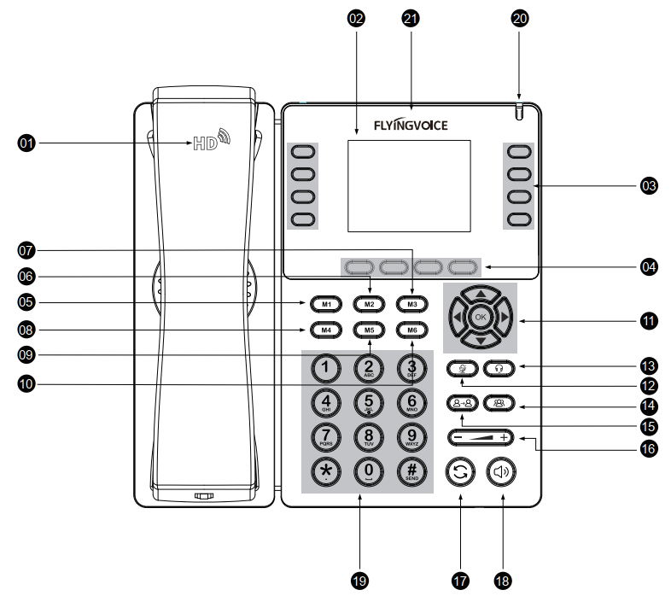

The main hardware components of the P23 Series IP phone are described as follows.

|  |  |  |
| --- | --- | --- |
| **NO.** | **Item** | **Description** |
| **1** | Handset | Handset to pick up and answer call |
| **2** | Phone Screen | Shows information about your phone, such as calls, messages, soft keys, time and date |
| **3** | Line Keys | Access your phone lines and features |
| **4** | Soft Keys | Access the function displayed on the screen above the soft keys. The soft keys change depending on what you are doing at the time |
| **5** | M1 | The default is speed dial, the number is empty and can be customized |
| **6** | M2 | The default is speed dial, the number is empty and can be customized |
| **7** | M3 | The default is speed dial, the number is empty and can be customized |
| **8** | M4 | The default is speed dial, the number is empty and can be customized |
| **9** | M5 | The default is speed dial, the number is empty and can be customized |
| **10** | M6 | The default is speed dial, the number is empty and can be customized |
| 11 | Navigation Keys | Scroll through information or options displayed on the screen. Access History and Directory respectively |
| OK Key | Confirms actions or answers incoming calls. |
| **12** | Mute Key | Toggles and indicates the mute feature. The key LED glows red when the call  is muted. |
| **13** | Headset Key | Toggles and indicates the headset mode. The key LED glows green when headset mode is activated. |
| **14** | Conference Key | Join the Conference call |
| **15** | Transfer Key | Transfers a call to another party |
| **16** | Volume Key | Adjusts the volume of the handset, headset, and speaker |
| **17** | Redial Key | Redials a previously dialed number |
| **18** | Speakerphone  Key | Toggles and indicates the hands-free (speakerphone) mode. The key LED glows green when the hands-free (speakerphone) mode is activated |
| **19** | Keypad | Provides the digits and special characters in context-sensitive applications |
| **20** | Power LED  Indicator | Indicates call status, message status, and phone’s system status |
| **21** | Logo | FLYINGVOICE Logo |

## LED Indicator

### Power LED Indicator

The power LED indicator indicates the call, message and phone's system status.

|  |  |
| --- | --- |
| **LED Status** | **Description** |
| Slowly-flashing red  (5 flashes in 1s) | The phone is ringing |
| Slowly-flashing red  (1 flashes in 1s, every 4s) | The phone receives missed calls or text message |
| Slowly-flashing red  (2 flashes in 1s) | The phone receives voice message |
| OFF | The phone is powered off or idle |

### Line Key LED

The line key LED indicators are associated with the status of phone lines and features.

**Line key LED** (associated with the phone line)

|  |  |
| --- | --- |
| **LED Status** | **Description** |
| Solid green | The line is registered or BLF is set to indicate that the monitored phone is idle |
| Fast-flashing red | The line receives an incoming call or the monitored phone is ringing |
| Red | The line is in conversation or BLF is set to indicate that the monitored phone is on a call |
| Off | The line is inactive |

## Screen and Icons

The user screens and icon indicators can help you navigate and understand the important information on the phone's status.

Topics

Idle Screen

Calls Screen

Icons in the Status Bar

Line Key Icons

Other Icons

### Idle Screen

The idle screen is made up of the status bar, line keys, and soft keys. The time & date in the status bar or middle of the screen varies by phone models.

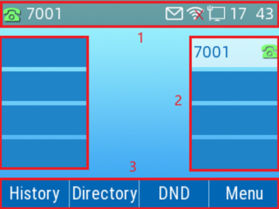

1. Status Bar: Display the default account, feature status icons, and the time. The status icons are displayed when features are activated.

2. Line Keys: Display the information associated with the line keys and feature keys on the phone.

3. Soft Keys: Display the information associated with the feature keys.

### Calls Screen

All of your active and held calls are displayed on the calls screen. You can press up or down navigation key to switch among calls.

Check with your system administrator to find out if this feature is available on the phone. When there is an active call and a held call, the calls screen is shown below:

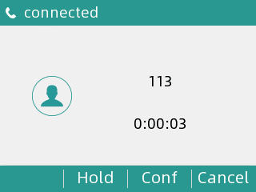

You can go to **Menu > Status** page to view Network and phone status. The phone screen is shown below:

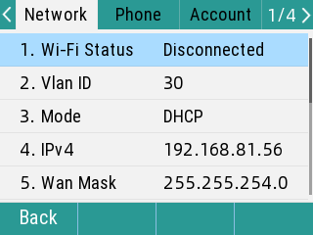

### Icons in the Status Bar

Icons in the status bar vary by phone models.

|  |  |  |  |
| --- | --- | --- | --- |
| **Icon** | **Description** | **Icon** | **Description** |
| 网络连接 | Wired network is available | 7 | Auto Answer |
| 2 | Wired network is unreachable | 8 | Do Not Disturb (DND) |
| 3 | Speaker mode | 9 | Keep Mute |
| 4 | Handset mode | 音量为0 | Ringer volume is 0 |
| 5 | Headset mode | 10 | Missed Calls |
| 6 | Voice Mail | 11 | Call Forward |
| 呼叫保持 | Call is on hold | 12 | Recording |
| 14 | Wi-Fi connected | 15 | Wi-Fi connection failed |
|  | USB drive connected |  | Text message |

### Line Key Icons

Icons on the line key that vary by phone models.

**Icon indicators** (associated with line)

|  |  |
| --- | --- |
| **Icon** | **Description** |
| 16 | The private line is registered successfully |
| 17 | Register failed |

### Other Icons

**Call History**

|  |  |
| --- | --- |
| **Icon** | **Description** |
| 19 | Received Calls |
| 18 | Placed Calls |
| 20 | Missed Calls |

**Contact**

|  |  |
| --- | --- |
| **Icon** | **Description** |
| 201 | Default Contact Picture |

**Call**

|  |  |
| --- | --- |
| **Icon** | **Description** |
| 21 | Waiting |
| 22 | Ringing |
| 23 | Calling |

Icons displayed on the LCD interface (text message icons).

|  |  |
| --- | --- |
| **Icon** | **Description** |
|  | Unread text message |
|  | Read text message |
|  | Sent messages / Outbox messages |
|  | Draft box information |

## 1.4 Entering Characters

You can use the keypad keys on your phone to enter or update field information.

The following table describes how to enter different characters using the keypad keys.

|  |  |
| --- | --- |
| **Task** | **Action** |
| Switch input modes | Press the **ABC**, **abc**, **Ab2**, **2aB**, or **123** soft key to switch the input modes. |
| Enter alphas | Select **ABC**, **abc**, **2aB** mode. press the keys labeled with letters until your desired letter appears. press a keypad key repeatedly to view the character options and stop when the letter you want to enter is displayed in the field. Wait one second, and then enter the next letter. |
| Enter numbers | Select **123** mode, press the corresponding keys. |
| Enter special characters | Select **ABC**, **abc**, **2aB** mode, press **\*** key or **#** key one or more times to enter one of the following special characters:  **\* key**: *.,'?!\-()@/:_;+&%=<>￡$¥¤[]{}~^¡¿§#"|  **# key**: #  In **123** mode, you can press the * key to choose the following special characters: **.*:/@[]**. |
| Insert space | Select **ABC**, **abc**, **2aB** mode, press the **0** key. |
| Delete one or more  characters | Position the cursor to the right of the character, and select the **Delete** soft key. |

# Chapter 2 Getting Started

This chapter describes the introductory operation of the P23 Series phone and covers the

For more information and help, please contact us.

**Topic**

Phone initialization

Phone Status

Basic network settings

Wireless network settings

## Phone initialization

After the phone is powered on, the following steps will be performed.

1. the "FLYINGVOICE" logo is displayed on the LCD interface

2. When the phone is initialized, wait for the progress bar to finish loading.

3. After the phone starts normally, it can obtain network configuration through DHCP.

By default, the phone obtains network configuration such as IP address, subnet mask, default gateway address and DNS server through DHCP server.

**Note:** If the phone cannot get the network configuration through DHCP server, please do the basic network settings on page 15.

## Phone Status

**Procedure**

You can press **Menu**, then press **Status** to view the Network and Phone status.

The phone screen is shown below:

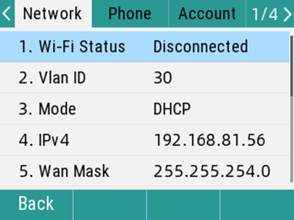

## Basic network settings

If the phone cannot get the network configuration through DHCP server, you need to set it manually.

The phone supports IP mode: IPv4, IPv6.

**Set the IP address mode through the phone interface：**

1. Press **Menu**->**Advanced Settings** (default password: admin)->**Network**->**WAN Port**

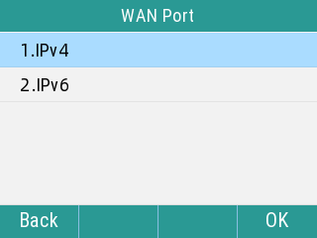

1. Select **IPv4** or **IPv6**
2. Press **Switch** key to switch the type of IPv4 WAN port, select **Static IP** and **DHCP**

**Set a Static IPv4 address through the phone interface：**

1. Press **Menu**->**Advanced Settings** (default password: admin)->**Network**->**WAN Port**->**IPv4**
2. Press **Switch** key to switch select **Static IP**
3. Enter the **IP address**, **Mask**, **Default Gateway**, **Primary DNS** and **Secondary DNS** in the corresponding area respectively

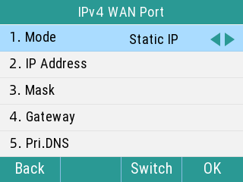

1. Press the **OK** to save the operation

## Wireless Network

You can connect the phones to a wireless network if Wi-Fi is available within the area. For more information, contact your system administrator.

**Topics**

Activating the Wi-Fi Mode

Connecting to the Wireless Network

Viewing the Wireless Network Information

Disconnecting the Wireless Network Connection

Deactivating the Wi-Fi Mode

### Activating the Wi-Fi Mode

You can activate the Wi-Fi mode to connect your phone to an available wireless network.

**Procedure**

1. Navigate to **Menu** > **Basic** > **Wi-Fi**.

2. Select **On** from the **Wi-Fi** field.

3. Select **OK**.

*The phone scans the available wireless networks in your area.*

### Connecting to the Wireless Network

After you have activated the Wi-Fi mode, you can connect the phone to the wireless network.

**Connecting to an Available Wireless Network Manually**

When you enable the Wi-Fi mode, the phone automatically connects to the saved wireless network, you can also connect it manually.

**Before You Begin**

Get the password of the wireless network from your system administrator. Make sure that the Wi-Fi mode is activated.

**Procedure**

1. Navigate to **Menu** > **Basic** > **Wi-Fi**.

2. Press the **Available Network(s)**.

3. Optional: To research the available network, select **Scan**.

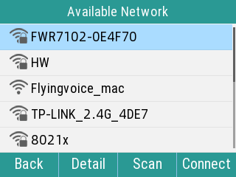

4. Select the desired wireless network and select **Connect**.

5. If the network is secure, enter its password.

6. Select **OK**.

### Viewing Wireless Network Information

You can view the wireless network information (for example, Profile Name, SSID or Signal Strength) when the Wi-Fi mode is activated.

**Procedure**

1. Navigate to **Menu** > **Basic** > **Wi-Fi** > **Available Network(s)**

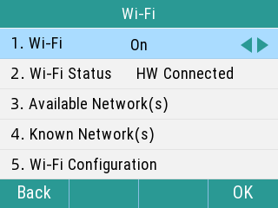

2. Select the desired network to view the detailed wireless network information.

If the phone is connected to a wireless network successfully, you can also navigate to **Menu** > **Basic**> **Wi-Fi** > **Wi-Fi Status** to view the connected wireless network information.

### Disconnecting Wireless Network Connection

When you no longer want to connect to the current wireless network, you can disconnect it.

**Procedure**

1. Navigate to **Menu** > **Basic** > **Wi-Fi**.

2. Select **Available Network(s)**.

3. Press the connected wireless network, and select **Discon**.

**Tip:** You can also disconnect the wireless network when deactivating the Wi-Fi mode.

### Deactivating the Wi-Fi Mode

You should deactivate the Wi-Fi mode when you need to connect your phone to the wired network.

**Note:** When the phone uses the Wireless connection the Ethernet cable connection in the same time, the Wireless connection has the higher priority.

**Procedure**

1. Navigate to **Menu** > **Basic** > **Wi-Fi**.

2. Select **Off** from the **Wi-Fi** field.

3. Select **OK**.

### Modify Wi-Fi Band

Switch WiFi scanning frequency band, only supported by P23GW

**Procedure**

1. The Wi-Fi scanning frequency band defaults is 2.4g.

2. Navigate to **Wi-Fi Configuration** > **Wi-Fi Band** > **Wi-Fi 2.4g or 5g**.

3. Select **OK** to restart to take effect.

## Registration

Usually, the system administrator will pre-configure the relevant parameters and deploy all phones centrally, in this case, the phones are usually already registered with accounts.

The P23 Series phone supports 8 account registrations. If the phone is not registered, you need to register it manually.

**Topic**

Phone interface Registration

Web Interface Registration

### Phone interface Registration

**You can register one or more accounts on the phone**

1. Press **Menu**->**Advanced Settings** (default password is admin)->**Account**

2. Select the account you want to set up, click **OK**

3. Press the **Switch** key to switch the account status, and choose to turn on

4. Fill in the corresponding information in the **Display Name**, **Registered Name**, **User Name**, **Password**, **Sip Server**, **SIP Port**, respectively

5. If you want to use outbound proxy server, please enter the corresponding server address in the corresponding proxy server option

6. Press the **OK** key to save the operation

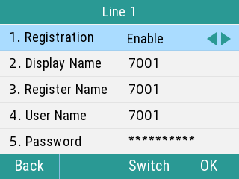

Repeat steps 2-6 to complete the registration of all accounts.

**Disable the account via the phone interface.**

1. Press **Menu**->**Advanced Settings** (default password is admin)->**Account**

2. Select the account you want to set, press Enter

3. Press **Switch** to switch the account status, select **Disable**

4. Press the **OK** Key to save

### Web Registration

**You can register one or more accounts on the webpage**

1. After checking the IP address of the phone, enter the IP address in the browser and enter the web management page of the phone

**Tip：**Default Administrator Username and Password are "admin"

2. Click **SIP Account->Line x,** drop down and select **Line Enable** to **enable**, fill in user information (**Display Name**, **Phone Name**, **Account**, **Password**), Proxy and Registration information (**Proxy server, Proxy port, Transport**)

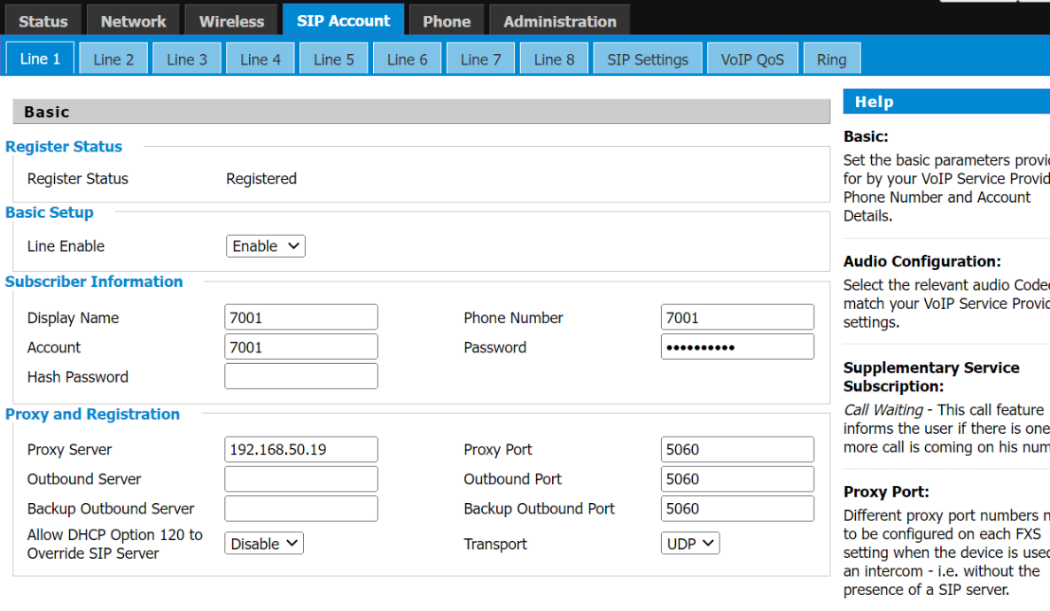

3. Click **Save & Apply** to save the operation

**Disable the account via the web interface：**

1. Click **SIP Account->Line x**, drop down and select Account **Disable**

**Tips**

Incorrect network settings may cause the network to be unavailable and may also have an impact on the performance of the network. To learn more about the parameters, please consult your system administrator.

## M1-M6 Configuration

M1-M6, the default type is SpeedDial, you need to configure it in the Web Page.

**Tips：**The value defaults to Null, the line defaults to Line1.

### Phone interface Registration

**Procedure**

1. Long press the **M1** key (M1~M6) -> Select the account -> fill in the number.

2. Click **Save**.

### Web interface Registration

**Procedure**

1. Press **Phone**-> **Programmable Key**

2. M1~M6->Fill in the number in the **value**

3. Click **Save** and wait for it to take effect.

***Note:*** *You can also Select the type or line you want, and fill in the value.*

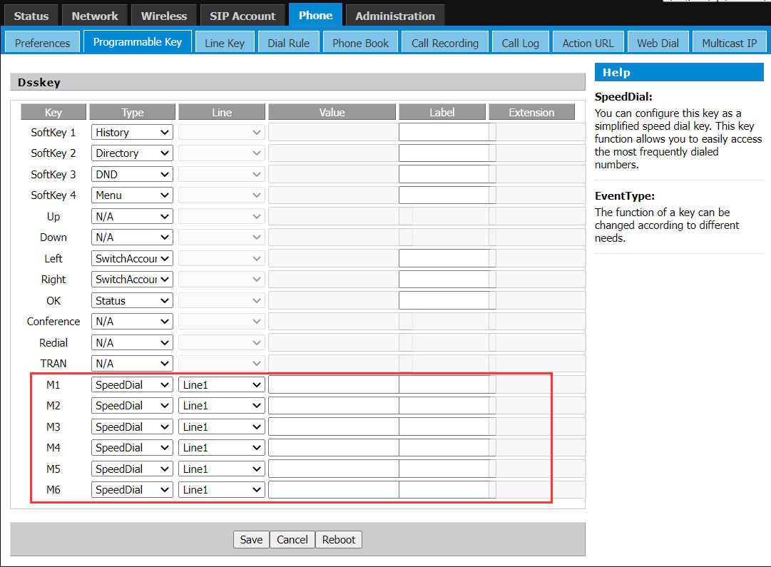

# Chapter 3 Call Features

You can use the phone to place and answer calls, ignore incoming calls, transfer a call to someone else, conduct a conference call and perform other basic call features.

**Topics**

Placing Calls

Answering Calls

Disabling Call Waiting

Silencing or Rejecting Incoming Calls

Ending Calls

Muting/Unmuting Audio

Holding and Resuming Calls

Redirecting Incoming Calls

Redirecting Incoming Calls

Call Waiting

Transferring Calls

Conference Calls

## 3.1 Placing Calls

You can use your phone like a regular phone to place calls in many ways easily.

**Topics**

Placing a Call from the Dialer

Placing Multiple Calls

Redialing a Number

Placing a Call from the Call History

Placing a Call from the Directory

### Placing a Call from the Dialer

The Dialer enables you to enter a number to place a call, and it displays a list of previously placed calls or contacts in your directory.

You can also select the desired contact from the search list, the placed call list or Directory.

**Procedure**

1. Do one of the following:

* Start typing a phone number.
* Select the desired line key.
* Pick up the handset, press the Speakerphone key  or the HEADSET key .

2. Enter a number or select a contact.

3. Select **Send**.

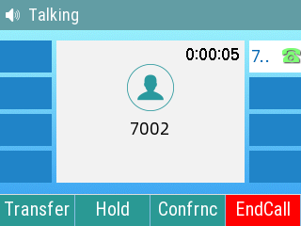

**Tip:** Your system administrator can enable the live dial-pad feature, which enables your phone to automatically dial out the phone number after some time without selecting **Send**.

### Placing Multiple Calls

When you are in a call, you can hold your current call and place a new call.

**Procedure**

1. Press **Hold** to place the original call on hold.

2. Press **NewCall**,enter the desired number or select a contact.

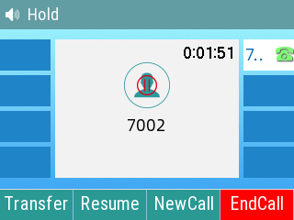

3. Select **Send**.

**Tip:** Only one call is active at any time, and other calls are on hold. You can press **Swap** to switch the call.

. 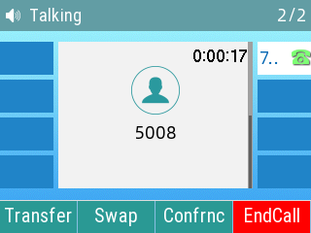

### Placing a Call from the Call History

You can place calls to contacts from the History list, which contains the calls that were recently placed, answered, missed, or forwarded.

**Procedure**

1. Press **History**.

*The phone screen displays* ***All/Missed/Dialled/Received*** *call records.*

2. Select the desired number, it will make the call automatically.

### Placing a Call from the Directory

You can place a call to a contact directly from your directory.

**Procedure**

1. Select **Directory** or navigate to **Menu** > **Directory** > **Local Contacts**.

2. Select the desired contact group or **All Contacts**.

3. Highlight the desired contact and press the desired number.

### Placing a Call using the RJ9 headset

Connect the headset, press  to activate the headset mode, enter the number and press the **Send** soft key.

### Placing a Call using the DECT headset

Connect the headset, enter the number and press the **Send** soft key.

**Tip:** After the connection is completed, LCD interface display "USB headset connected".

**Brands and models of DECT headsets supported by P23 series IP phones.**

|  |  |
| --- | --- |
| Brands | Models |
| Plantronics | CS520 |
| CS540 |
| Jabra | PRO 920 |
| PRO 925 |
| PRO 9460 |
| PRO 9470 |
| Motion Office |
| Engage 65 Stereo&Mono |
| Jabra | Engage 75 Convertible |
| Engage 75 Stereo&Mono |
| Sennheiser | SDW5016 |

## 3.2 Answering Calls

When you receive a call, you can choose to answer it manually or automatically.

**Topics**

Answering a Call

Answering a Call When in a Call

Answering a Call Automatically

### Answering a Call

When you receive an incoming call, the phone rings and the screen display the information of the incoming call. You can choose to answer the incoming call.

**Procedure**

1. Do one of the following:

* Pick up the handset.
* Press the Speakerphone key .
* Press the HEADSET key.
* Press **Answer**.

*The call is answered in the speakerphone (hands-free) mode by default.*

**Tip:** You can also select an RJ headset or DECT headset to answer.

### Answering a Call When in a Call

You can answer a call when there is already an active call on your phone.

When you are in an active call and an incoming call arrives on the phone, a call waiting tone beeps, and the incoming call information is displayed.

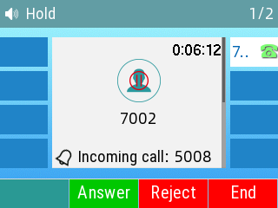

**Procedure**

1. Select **Answer**.

*The active call is placed on hold, and the incoming call becomes active.*

**Tip:**

You can disable the call waiting feature to reject the incoming call automatically during a call.

### Answering a Call Automatically

The auto answer enables you to automatically answer an incoming call in speakerphone (hands-free) mode when your phone is idle.

**Tip:** When you are in an active call and an incoming call arrives on the phone, the incoming call will not be automatically answered even if the auto answer is enabled.

Your system administrator can configure the phone to automatically answer the incoming call after ending all calls.

#### Phone interface

**Procedure**

1. Navigate to **Menu** > **Features** > **Auto Answer** > **Auto Answer Settings**.

2. Enable the **Auto Answer**.

3. Select **OK**.

#### Web interface

**Procedure**

1. Navigate to **Phone**-> **Preferences**-> **Miscellaneous**->**Auto Answer All Phone Number** -> **Save & Apply**

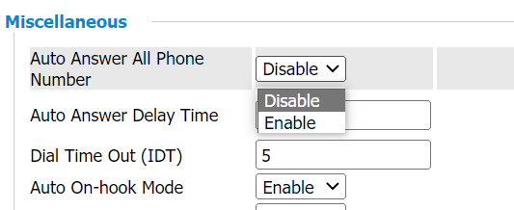

## 3.3 Disabling Call Waiting

If the call waiting feature is disabled, when there is already a call, the new incoming call will be rejected automatically.

**Procedure**

1. Navigate to **Menu** > **Features** > **Call Waiting** > **Call Waiting Settings**.

2. Select **Disable**.

3. Select **OK**.

## 3.4 Silencing or Rejecting Incoming Calls

When you receive an incoming call, you can choose to silence or reject the call instead of answering.

### Rejecting Calls with Do Not Disturb (DND)

You can enable DND to reject all incoming calls automatically when you do not want to be interrupted.

**Topics**

Rejecting Calls with DND

Deactivating DND

#### Rejecting Calls with DND

**Procedure**

1. Navigate to **Menu** > **Features** > **DND**.

2. Select **Enable** from the DND Status field.

3. Select **OK**.

*The DND icon* *appears in the status bar.*

**Tip:** To activate or deactivate DND quickly, press the DND soft key when the phone is idle.

#### Deactivating DND

You can deactivate DND when you are ready to resume receiving calls again.

**Procedure**

1. Navigate to **Menu** > **Features** > **DND**.

2. Select **Disable** from the DND Status field.

3. Select **OK**.

*The DND icon* *disappears from the status bar.*

**Tip:** To deactivate DND quickly, press the **DND** soft key when the phone is idle.

## 3.5 Ending Calls

You can end the current call at any time.

**Procedure**

1. Do one of the following:

* If you are using the handset, press the **Cancel** key or hang up the handset.
* If you are using the headset, press the **Cancel** key.
* If you are using the speakerphone, press the **Cancel** key, Speakerphone key .

## 3.6 Muting/Unmuting Audio

When you are in a call, you can mute the audio, so that you can hear the other person, but they cannot hear you.

**Procedure**

1. Press the MUTE key during a call.

2. Press the MUTE key again to unmute the call.

## 3.7 Holding and Resuming Calls

You can place an active call on hold and resume the call when you are ready. When you place a call on hold, the held party may hear the music played by its sever.

**Topics**

Holding a Call

Resuming a Held Call

### Holding a Call

You can place an active call on hold on your phone.

**Procedure**

Press **Hold** during a call.

The phone ignores engaged audio devices (handset or headset) and plays beep in the Speakerphone (hands-free) mode by default.

### Resuming a Held Call

You can view and resume a held call on the phone.

**Procedure**

Press **Resume**.

If multiple calls are placed on hold, select the desired call first.

**Tip:** When you have multiple calls on the phone and the current call is active, you can select **Swap** to swap to the held call.

## 3.8 Redirecting Incoming Calls

When you are not available to answer calls on your phone, you can forward the calls to another phone.

**Topics**

Forwarding All Incoming Calls to a Contact

Forwarding All Incoming Calls on All Lines

Deactivating Call Forward

Diverting Calls to a Contact

### Forwarding All Incoming Calls to a Contact

You can set up the forwarding type which enables your phone to forward all incoming calls to a contact. There are three types of forwarding:

**Always Forward:** Forwards all incoming calls immediately.

**Busy Forward:** Forwards incoming calls when you are busy in a call.

**No Answer Forward:** Forwards incoming calls when no one answers the calls.

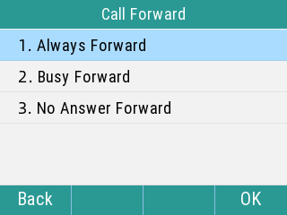

### Forwarding All Incoming Calls on All Lines

You can forward all incoming calls on the phone.

**Before You Begin**

Check with your system administrator if the forward on code or off code is required. If required, get it from your system administrator.

**Procedure**

1. Navigate to **Menu** > **Features** > **Call Forward**.

2. Select the desired forwarding type and select **Enable** from the corresponding field.

3. Enter the contact number you want to forward incoming calls to in the **Forward to** field.

4. If you select the **No Answer Forward** option, select the desired ring time to wait before forwarding from the field.

5. Optional: Enter the always/busy/no answer forward on code or off code respectively in the **On Code** or **Off Code** field.

6. Select **OK**.

*The call forward icon* *appears in the status bar.*

### Deactivating Call Forward

You can deactivate call forward when you no longer want to forward your calls.

**Procedure**

1. Navigate to **Menu** > **Features** > **Call Forward**.

2. Select the desired forwarding type and select **Disable** from the corresponding field.

3. Select **OK**.

### Diverting Calls to a Contact

You can divert all incoming calls from a particular contact to another contact. Auto divert has precedence over call forward.

**Procedure**

1. Select **Directory (Dir)** or navigate to **Menu** > **Directory** > **Local Contacts**.

2. Select the desired contact group or All Contacts.

3. Highlight the desired contact, and select **Detail**.

4. Edit the contact information.

5. Enter a contact’s number you want to divert the call to in the Auto Divert field.

6. Select **Save**.

## 3.9 Call Waiting

The call waiting feature can be turned on or off.

If the call waiting feature is enabled, new incoming calls can be answered during a call.

If call waiting is turned off, new calls will be automatically rejected during the call and a busy tone will be indicated.

### Phone interface configuration

**Procedure**

1. Press **Menu**->**Features**->**Call Waiting**->**Call Waiting Settings**, click **Switch** key, select On

2. Press the **OK** key to save the operation

### Web interface configuration

**Procedure**

1. **SIP Account**-> **Line x** -> **Call Waiting**, turn on call waiting, **save and apply.**

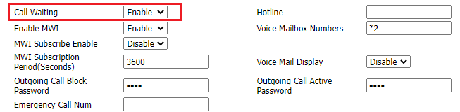

## 3.10 Transferring Calls

During a call, you can transfer the call to another contact. You can use one of two ways:

* **Blind Transfer:** Transfer a call directly to the third party without consulting.
* **Attended Transfer (Consultative Transfer):** Transfer a call with prior consulting.

**Topics**

Performing a Blind Transfer

Performing an Attended Transfer

### Performing a Blind Transfer

You can transfer a call to another contact immediately without consulting with her/him first.

**Procedure**

1. Press **Transfer (Trans)** during a call.

2. Do one of the following:

* Enter the number or select a contact from the placed call list you want to transfer to.
* Press **Directory (Dir)**. Select the desired contact from the Directory list.

1. Press TRAN key or BXFER to complete the transfer.

**Tip:** If you are using a handset, the transfer can be completed by hanging up the handset.

Your system administrator can also set your phone to perform attended transfer when using a Transfer key.

### Performing an Attended Transfer

You can transfer a call to another contact after consulting with her/him.

**Procedure**

1. Press **Transfer (Trans)** during a call.

2. Do one of the following:

* Enter the number or select a contact from the placed call list you want to transfer to.
* Press **Directory (Dir)**. Select the desired contact from the Directory list.

3. Wait until the third party answers the call, press TRAN key to complete the transfer.

## 3.11 Conference Calls

The phone supports a 6-way local conference and multi-way network conference. During the conference, follow these tips:

* Use the handset or a headset if you're in an open environment.
* Mute your microphone when you are not speaking, especially in noisy environments.
* Avoid tapping or rustling papers near the microphone.
* Speak in your normal voice without shouting.

**Tip:** Check with your system administrator to find out if the local conference is enabled on your phone.

**Topics**

Setting Up a Local Conference Call

Holding or Resuming a Conference Call

Splitting a Conference Call

Ending a Conference Call

### Setting Up a Local Conference Call

You can set up a local conference call with up to five contacts.

**Procedure**

1. Place a call to the first party.

2. When the first party answers the call, select **Conference (Confrnc)** to place a new call.

The active call is placed on hold.

3.Dial the second party’s number.

You can also select the desired contact from the search list, or select a contact from the placed call list or Directory before you enter the number.

1. Wait until the second party answers the call, press the **Conference (Confrnc)** key.
2. At this point, a three-person meeting was generated.

### Holding or Resuming a Conference Call

When you place a conference call on hold, other participants cannot hear each other until you resume the held conference call.

**Procedure**

1. Press **Hold** to place the conference on hold.

2. Press **Resume** to resume the held conference call.

### Splitting a Conference Call

You can split the conference call into individual calls. After the split, the conference call ends, and other parties are on hold. Press **Resume** to resume one of the held call or hang up.

**Procedure**

1. Select **Split**.
2. Press the navigation key up or down to select a held call.
3. Press Resume.

### Ending a Conference Call

When you end the conference call, the other parties drop the call.

**Procedure**

1. Select **End Call (EndCall)**.

## 3.12 USB Flash Drive Recording

**Topic**

Enable USB flash drive record

Call recording

View Recording Files

Phone setting recording

Web setting recording

### Enable USB Flash Drive Recording

1. Insert the USB flash drive into the USB port of the phone, the status bar shows the icon.

2. Press **Menu**->**Features**->**USB Record.**

3. Pressor to select USB Record **Enable.**

4. Press the **OK** key.

### Call Recording

1. Dial an extension of the other party, press **More**->**Start REC.**

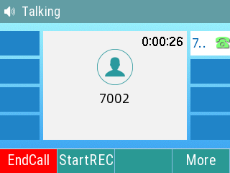

2. When finished with the recording, press the **StopReC** key to Pause the recording.

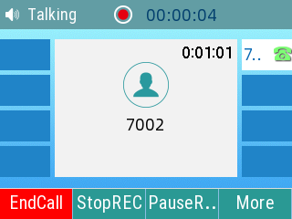

3. During the recording process, you can press the **PauseREC** and **ResumeREC** keys. It also supports stop recording and then start recording again, you can record multiple recordings

### View Recording Files

1. Press **Menu**->**Features**->**USB Record**->**Recording Files**
2. Search for recording files: enter the file name in the search box to find the file
3. Listen to the recording file: press the recording file, press the play key to listen to the recording content, you can also press the **Fast Forward** key, **Fast Rewind** key, drag the screen progress bar to listen to the specified audio area.

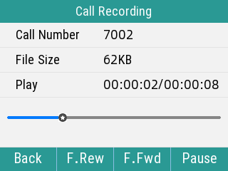

1. View recording details: press the **Option** to the right of a recording file in the list and Select **Details.**

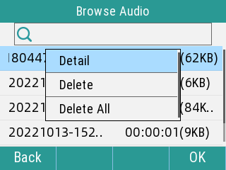

1. Delete a single recording file: press **Delete** in the pop-up box, prompting "Delete selected item?".
2. Delete all recording file: press **Delete All** in the pop-up box, prompting "Delete All?".

### Recording Settings on the LCD screen

1. Press **Menu**->**Features**-> **USB Record**->**Recording Settings**
2. Press the **Call Recording Mode**, press or, select the call recording mode **Manual Recording or Automatic Recording** (The default is Manual Recording), press the **OK** key.

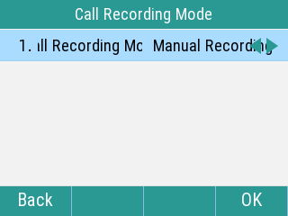

1. Press **Recording File Settings**, Swap Delete manually or Auto Delete when the U flash drive capacity is full (default is Delete manually), press the **OK** key.

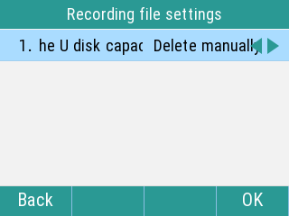

1. You can press **Browse storage space** to view the **Total** space, **Used** space and **Free**(available) space.

### Recording Settings on the Web Interface

1. On your phone, press **Menu**->**Status**, check the IPv4 address of the phone, log into the phone’s web interface with it, go to **Phone** -> **Call Recording** page.

2. Modify the recording settings: **Recording query** -> **Recording settings**, drop down and select **Recording mode** as U flash drive recording, you can select the call recording as **Manual recording**/**Automatic recording**, select the **Recording deletion mode** as manual deletion/automatic deletion, click **save** key.

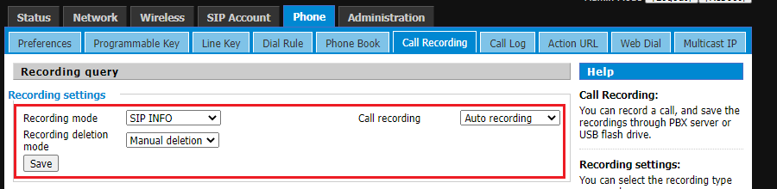

3. Search for recording files: **Recording query**->**Recording files**, enter the recording file name in the search box, press the **SCAN** key to retrieve the desired recording file.

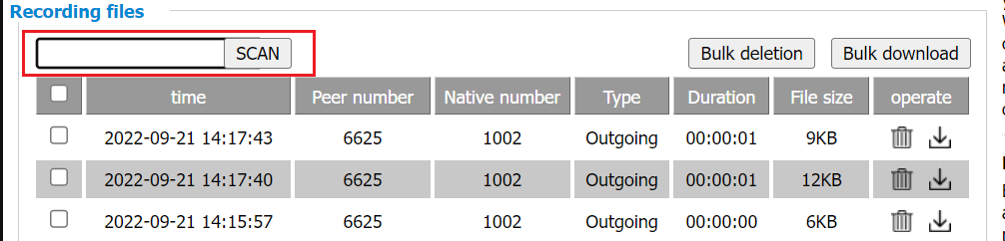

4. Delete recording file: In the **Recording query**->**Recording files** page, select the desired file, click the **delete** icon on the right side of the file list, or click **Bulk deletion** after selecting multiple files, the interface pops up a prompt box, click **OK.**

5. Download recording file: In the **Recording query** -> **recording files** page, click the **download** icon on the right side of the file list or click **Bulk download** after selecting multiple file

### Upload to Third-party Recording Server

P2X phone supports uploading local recording files to a designated third-party server (URL) via USB drive recording, either manually or automatically. This facilitates centralized recording storage and management for enterprises.

**Automatic Upload of USB Recording Files to Recording Server:**

1. On the phone, navigate to: **Phone** -> **Call Recording** -> **Recording Settings**.

2. Under Recording Mode, select USB Recording and enable **Upload to URL** (supports TFTP/FTP).

Example:

TFTP Address: tftp://192.168.10.8 (No authentication required for TFTP)

or FTP Address: ftp://192.168.10.8 (Username/password must be provided if required by the server).

3. Select **Upload Method** -> **Auto upload**. Optionally enable Automatically Delete Local File After Upload (Disable/Enable).

4. Click **Save**.

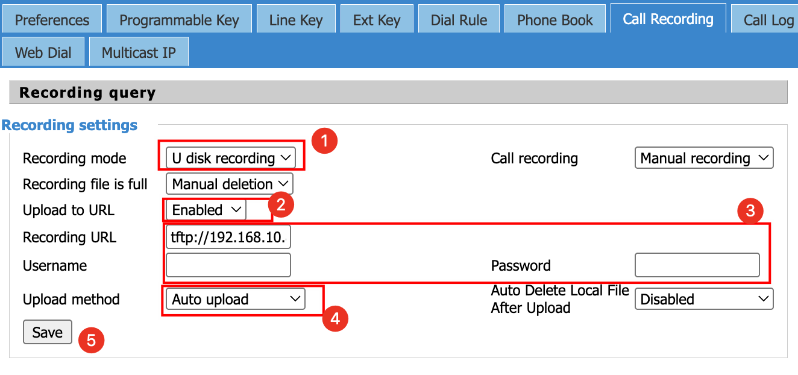

**Manual Upload of USB Recording Files to Recording Server:**

The phone supports manually uploading local recording files from the USB drive to the recording server (URL). This method retains local files after upload.

1. On the phone, navigate to: **Phone** -> **Call Recording** -> **U disk Record file**.

2. Select the file(s) to upload and click the **Upload** button.

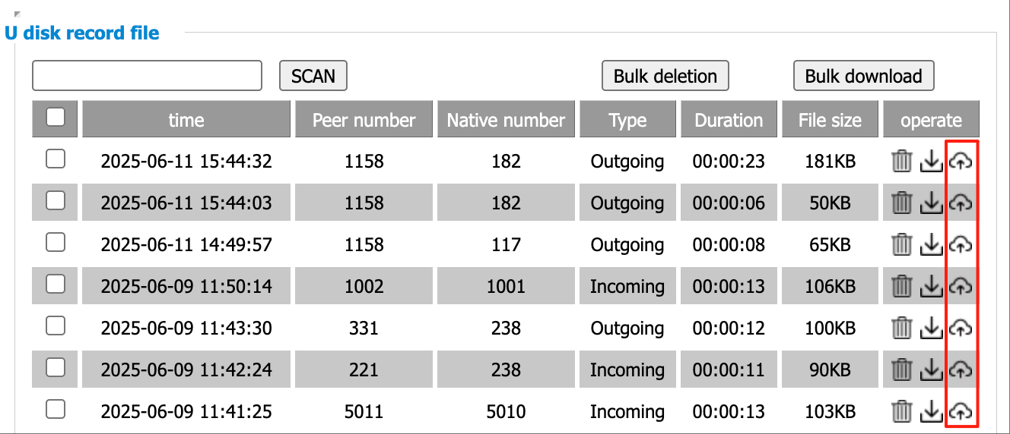

# Chapter 4 Advanced Call Features

You can perform some server-dependent tasks on the phone. Contact your system administrator to find out if your phone supports these advanced call features.

**Topic**

Paging

Voice Mail

Text Message

MWI (Message Waiting Indicator)

Directory

Remote Phone Book

LDAP

Call History

Hot desking

Beeper

## 4.1 Intercom

The server side configures the account to use the intercom function.

**Tip:** Not all servers support intercom function. To find out more information, please contact your system administrator.

### Configuring Intercom function

The server side configures the account to use the intercom function, and sets up the paging/intercom group number.

**Procedure：**

1. Finish configuring paging on the PBX

2. Then log into the phone's web interface, go to **Phone**->**Line key** page, **type** select **Intercom**, enter the group number into the value, then click the **Save** button.

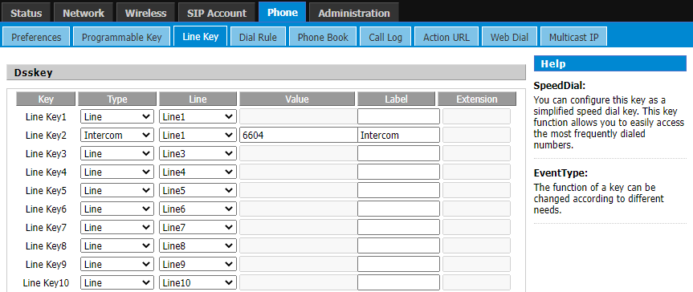

3. After that, you can press the configured programmable key to use the function.

### Using intercom

Intercom supports the following functions：

* Calling intercom account
* Answering intercom calls

**Calling intercom account：**

1. When the phone is in standby status, press the **Intercom key** or **Intercom programmable key** to call the intercom number on the server side that has the Intercom function enabled.

2. Press the **Speakerphone key** or **ENDCall** soft key to end the call.

**To answer intercom call：**

The called party is automatically connected to the call, no need to answer it manually.

## 4.2 Paging

You can use the paging feature to easily and conveniently send time-sensitive announcements to every member of your paging group.

**Tip:** Paging is not supported by all servers. For more information, please contact your system administrator.

### Configuring Paging function

The server side configures the account to use the paging function, and sets up the paging/intercom group number.

**Procedure：**

1. Finish configuring paging on the PBX

2. Then log into the phone's web interface, go to **Phone**->**Line key** page, **type** select **Paging**, enter the group number into the value, then click the **Save** button.

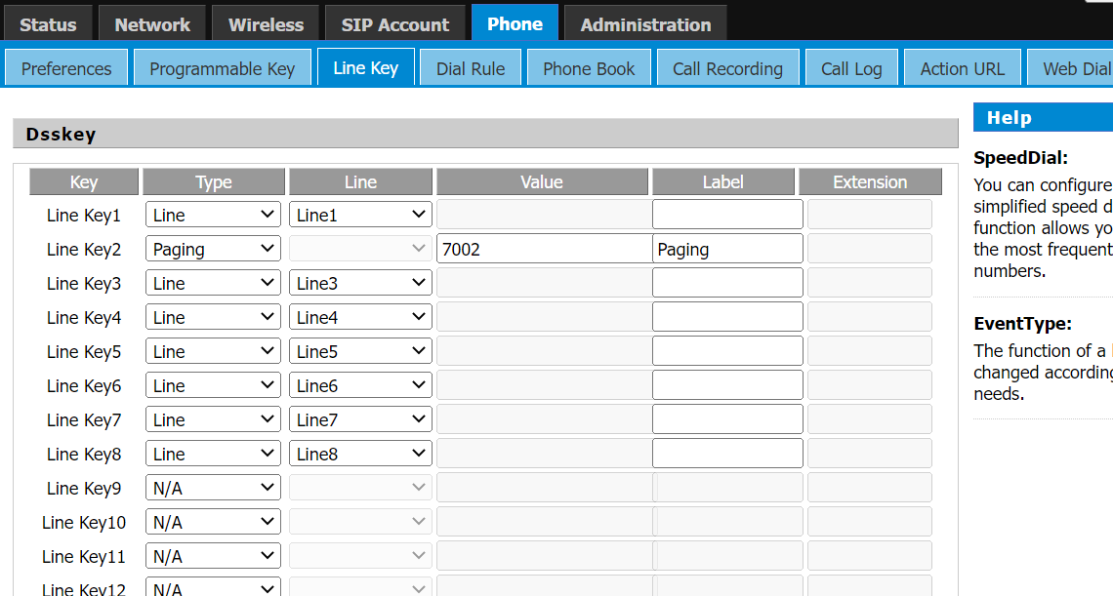

3. After that, you can press the configured programable key to use the function.

### Using Paging

Paging supports the following functions.

* Calling paging account
* Answering paging calls

**Calling a paging account：**

1. When the phone is in standby status, press the **Paging key** or **Paging programmable key** to call the paging number on the server side that has the paging function enabled.

2. Press the **Speakerphone key** or **ENDCall** soft key to end the call.

**Answering a paging call：**

When there is a paging incoming call, the phone will answer the call automatically. You can

press the **Speakerphone key** and the **ENDCall soft key** to end the call.

## 4.3 Voice Mail

Voice Mail feature allows you to leave voice messages for someone or listen to your voice mail messages on your IP phones.

This feature is set up on the server-side and not all servers support this feature.

**Topics**

Leaving Voice Mails

Listening to Voice Mails

### Leaving Voice Mails

You can leave a voice mail to someone who is busy or inconvenient to answer the call.

**Procedure**

1. Follow the voice prompts to leave a voice mail.

2. Hang up to complete the voice mail.

### Listening to Voice Mails

You can listen to your voice mails on the phone, to obtain voice information sent by a contact.

**Before You Begin**

You need to set the voice mail code in advance.

**Procedure**

1. Navigate to **Menu** > **Message** > **Voice Mail**.

The phone screen displays the amount of new and old voice mails.

2. Highlight an account, and then select **Connect**.

3. Follow the voice prompt to listen to your voice mails.

**Tip:** When the phone prompts that the phone receives a new voice mail, you can press the **Connect** soft key to dial out the voice mail access code directly.

## 4.4 Text Message

The phone supports the functions of newly sending text messages, viewing sent text messages, receiving and viewing read/unread text messages, saving sent failed text messages, deleting text messages, etc. The main contents include the following.

* New Message
* Inbox
* Sentbox
* Outbox
* Draftbox

When a new text message is received, the power indicator flashes red slowly, the LCD interface indicates "n New text messages", and the voice message icon  is displayed in the status bar of the main interface.

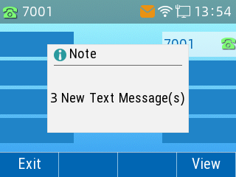

**Description:** After exiting the text message prompt window, the unread prompt window will not pop up again until there is a new text message, or an account with an unread text message after re-registration.

### New Message

**Procedure**

1. Press **Menu**->**Message**->**Text Message**->**New Message**

2. Enter the text message content, and the text message cannot be empty

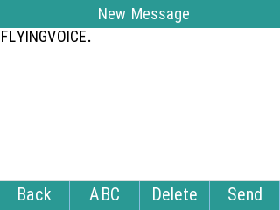

3. When finished, Press **Send** soft key, press the or key to switch the sender account, and then press the or key to fill in the recipient account.

4. After filling in the message, press the **Send** soft button, and if "**Sending Message…**" is prompted, it means the message has been sent to the recipient, if "**Fail to send** " is prompted, it means the recipient does not exist or other errors, the text message will be saved in the **Outbox** and can be changed and resend.

### Viewing text messages

#### To view received messages.

**Procedure**

1. Press **Menu**->**Message**->**Text Message**->**Inbox**

2. You can select one message and press the **View** to view the content of this message.

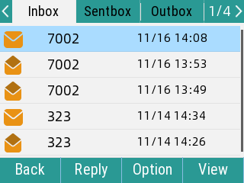 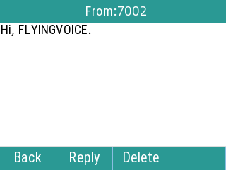

When viewing a text message, you can press the **Reply** to reply to the message directly; you can also press the **Delete** key to delete the message, or press **Option** in the received list to select **Delete** or **Delete All**.

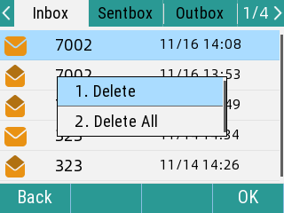 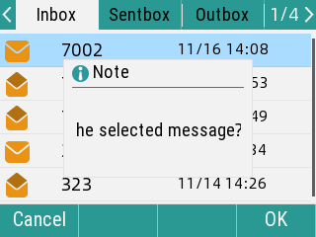

#### To view sent messages:

**Procedure**

1. Press **Menu**->**Message**->**Text Message**->**Sentbox**

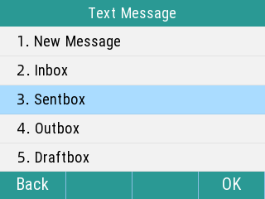

2. You can select one message and press the **View** to view the content of this message.

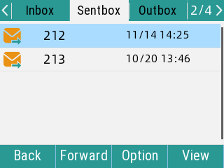

When viewing a text message, you can press **Forward** to transfer the message to another account; you can also press the **Delete** to delete the message, or press the **Option** in the Sentbox message list to select **Delete** or **Delete All**.

### Save Text message

**Save to outbox:** When sending a text message, it will be automatically saved to the **outbox** after sending failure.

**Procedure**

1. Press **Menu**->**Message**->**Text Message**->**Outbox.**

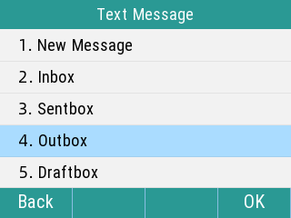

2. Display the list of failed messages, you can one message, press the View to view the message content

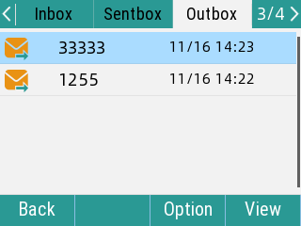

When viewing a text message, you can press **Forward** to transfer the message to another account; you can also press the **Delete** to delete the message, or press the **Option** in the Sentbox message list to select **Delete** or **Delete All**.

**Save to Draftbox:** When sending a message, if it is not sent out and you quit editing the message, it will be automatically saved to the draftbox

**Procedure**

1. Press **Menu**->**Message**->**Text Message**->**Draftbox**

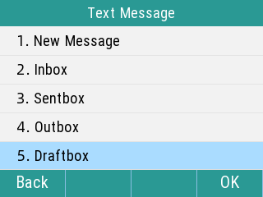

Display the list of unsent messages, select one message, and press **Send** to send the text message directly

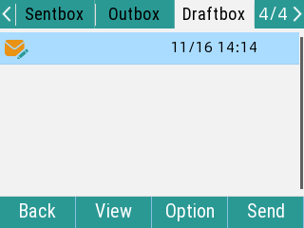

Press **View** to view the text message; or press the **Option** to **Delete** or **Delete all**

## 4.5 MWI (Message Waiting Indicator)

When a voice message is received, the phone will prompt messages, the voice message icons appear on the LCD interface, and the power indicator slowly flashes red. When all voice messages are checked or deleted, the voice icon disappears and the power indicator turns off.

**Tip:** Not all servers support the MWI function. For more information, please consult your system administrator.

|  |  |
| --- | --- |
| **Option** | **Description** |
| **MWI Enabled** | Enable or disable MWI service |
| **MWI Subscription Enabled** | Before the MWI subscription cycle expires, the phone resends the MWI subscription request. |

**Tip:** The type of MWI subscription service used by the phone (account-based or voice-message number-based) depends on the server selected. For more information, please consult your system administrator.

**Procedure**

To set up MWI enable via the web interface.

1. Click **SIP Account**->**Line x**->Supplementary Services

2. Enable MWI->Select **Enable**(Default Enable)

3. MWI subscription enable->select **Enable**

4. Click **Save & Apply** the save operation

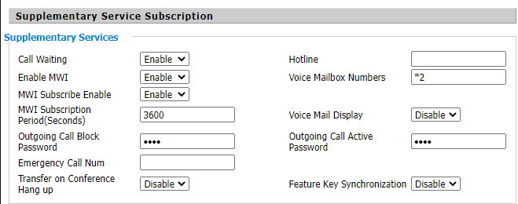

## 4.6 Directory

The phone provides several types of phone directories, which can be customized by your system administrator.

**Topics**

Local Contacts

Blacklist

### Local Contacts

You can store up to 2000 contacts in your local directory, you can search, add, edit and delete a contact.

**Topics**

Managing the Local Directory Groups

Managing the Local Directory Contacts

Moving a Local Directory Contact to Blacklist

Searching for Contacts

#### Managing the Local Directory Groups

You can manage the Local Directory groups when the phone is idle.

**Topics**

Adding Contact Groups

Editing Contact Groups

Deleting Contact Groups

##### Adding Contact Groups

To organize your contacts and make them easier to find, you can add additional groups in the Local Directory.

**Procedure**

1. Select **Directory** or navigate to **Menu** > **Directory** > **Local Contacts**.

2. Select **AddGrp**.

3. Enter the desired group name and select **Ring Type**.

4. Select **Save**.

##### Editing Contact Groups

You can change or add the group's information.

**Procedure**

1. Select **Directory** or navigate to **Menu** > **Directory** > **Local Contacts**.

2. Highlight the desired group.

3. Select **Option** > **Detail**.

4. Edit the group information.

5. Select **Save**.

##### Deleting Contact Groups

When you delete a contact group, the contacts in the group will not be deleted. You can view the contacts in **All Contacts** list.

**Procedure**

1. Select **Directory** or navigate to **Menu** > **Directory** > **Local Contacts**.

2. Highlight the desired group.

3. Select **Option** > **Delete**.

*The phone prompts you whether to delete the group.*

4. Select **OK**.

#### Managing the Local Directory Contacts

You can manage the Local Directory contacts when the phone is idle.

**Topics**

Adding Contacts

Viewing Contacts

Editing Contacts

Deleting a Contact

Deleting All Contacts

##### **Adding Contacts**

When you add a contact to your Local Directory, you can choose how much information you want to enter for your contact. You are required to enter a contact name at least for each new contact.

**Procedure**

1. Select **Directory** or navigate to **Menu** > **Directory** > **Local Contacts**.

2. Select the desired contact group or **All Contacts**.

3. Select **Add**.

4. Enter your contact's information.

5. Select the desired account from the **Account** field.

6. Select **Save** .

##### **Viewing Contacts**

You can view the local contacts from the Local Directory on your phone.

**Procedure**

1. Select **Directory** or navigate to **Menu** > **Directory** > **Local Contacts**.

2. Select the desired contact group or **All Contacts**.

*The contact names are displayed in alphabetical order.*

##### **Editing Contacts**

You can update your contacts' information.

Procedure

1. Select **Directory** or navigate to **Menu** > **Directory** > **Local Contacts**.

2. Select the desired contact group or **All Contacts**.

3. Highlight the desired contact, and select **Detail**.

4. Edit the contact information.

5. Select **Save**.

##### **Deleting a Contact**

You can delete any contact from the Local Directory.

**Procedure**

1. Select **Directory** or navigate to **Menu** > **Directory** > **Local Contacts**.

2. Select the desired contact group or **All Contacts**.

3. Click on the right side of the list-**more**, and select **Delete**.

**Tip：**The phone prompts you whether to delete the contact.

1. Select **OK**.

##### **Deleting All Contacts**

You can delete all contacts from the Local Directory.

**Procedure**

1. Select **Directory** or navigate to **Menu** > **Directory** > **Local Contacts**.

2. Select the desired contact group or **All Contacts**.

3. Select **Option** > **Delete All**.

*The phone prompts you whether to delete all contacts.*

1. Select **OK**.

#### Moving a Local Directory Contact to Blacklist

You can move a contact in the Local Directory to blacklist. Incoming calls from this contact will be rejected automatically.

**Procedure**

1. Select **Directory** or navigate to **Menu** > **Directory** > **Local Contacts**.

2. Select the desired contact group or **All Contacts**.

3. Select the desired contact, and select **Option** > **Add to Blacklist**.

*The phone prompts you whether to move to the blacklist.*

4. Select **OK**.

#### Searching for Contacts

In the Local Directory, you can enter search criteria to find your desired contact quickly.

**Procedure**

1. Select **Directory** or navigate to **Menu** > **Directory** > **Local Contacts**.

2. Select **Search**.

3. Enter your search criteria in the search field.

### Blacklist

Incoming calls from the Blacklist are rejected automatically.

**Topics**

Adding a Blacklist Contact

Viewing Blacklist Contacts

Editing a Blacklist Contact

Deleting Blacklist Contacts

Moving a Blacklist Contact to the Local Directory

#### Adding a Blacklist Contact

You can add a blacklist contact on the phone to prevent someone from calling you.

**Procedure**

1. Navigate to **Menu** > **Directory** > **Blacklist**.

2. Select **Add**.

3. Enter the blacklist contact’s information.

4. Select **Save**.

#### Viewing Blacklist Contacts

You can view the blacklist contacts from the Blacklist on your phone.

**Procedure**

1. Navigate to **Menu** > **Directory** > **Blacklist**.

#### Editing a Blacklist Contact

You can update your blacklist contacts' information.

**Procedure**

1. Navigate to **Menu** > **Directory** > **Blacklist**.

2. Select the desired blacklist contact, and select **Option** > **Detail**.

3. Edit the blacklist contact information.

4. Select **Save**.

#### Deleting Blacklist Contacts

You can delete one or all blacklist contacts. If a contact is removed from the blacklist, you can answer the call from the contact normally.

**Topics**

Deleting a Blacklist Contact

Deleting All Blacklist Contacts

##### Deleting a Blacklist Contact

If you want to answer a call from a specific contact, you need to remove it from the Blacklist.

**Procedure**

1. Navigate to **Menu** > **Directory** > **Blacklist**.

2. Select the desired blacklist contact.

3. Select **Option** > **Delete**.

*The phone prompts you Delete selected item.*

1. Select **OK**.

##### Deleting All Blacklist Contacts

You can delete all contacts from the Blacklist when you are ready to answer calls from them again.

**Procedure**

1. Navigate to **Menu** > **Directory** > **Blacklist**.

2. Highlight the desired blacklist contact, select **Option** > **Delete All**.

*The phone prompts you whether to delete all contacts.*

3. Select **OK**.

#### Moving a Blacklist Contact to the Local Directory

You can move a blacklist contact to a Local Directory. Incoming calls from this contact will not be rejected automatically.

**Procedure**

1. Navigate to **Menu** > **Directory** > **Blacklist**.

2. Select the desired contact, and then select **Add to Contact list**.

*The phone prompts you whether to move to contact.*

3. Select **OK**.

## 4.7 Remote Phone Book

The remote phone book is a centrally maintained phone book, stored on the remote server. Users only need the access URL of the remote phone book. The IP phone can establish a connection with the remote server and download the phone book, and then display the remote phone book entries on the phone.

**Topics**

Remote phonebook updated to local (xml)

Remote Phonebook

### Remote phonebook updated to local (xml)

Remote Phone book is to download all the server's Phonebook(.xml) to the phone Local Contacts, you can see the complete organization structure and contact information.

**Configure Remote phonebook (.xml) to Local Contacts via Web UI:**

1. Go to the web interface and click **Phone** -> **Directory**-> **Remote Phonebook update to local (xml).**

2. Fill in the **URL** (remote phonebook address), the detection interval is 3600s by default.

3. Click **Save**

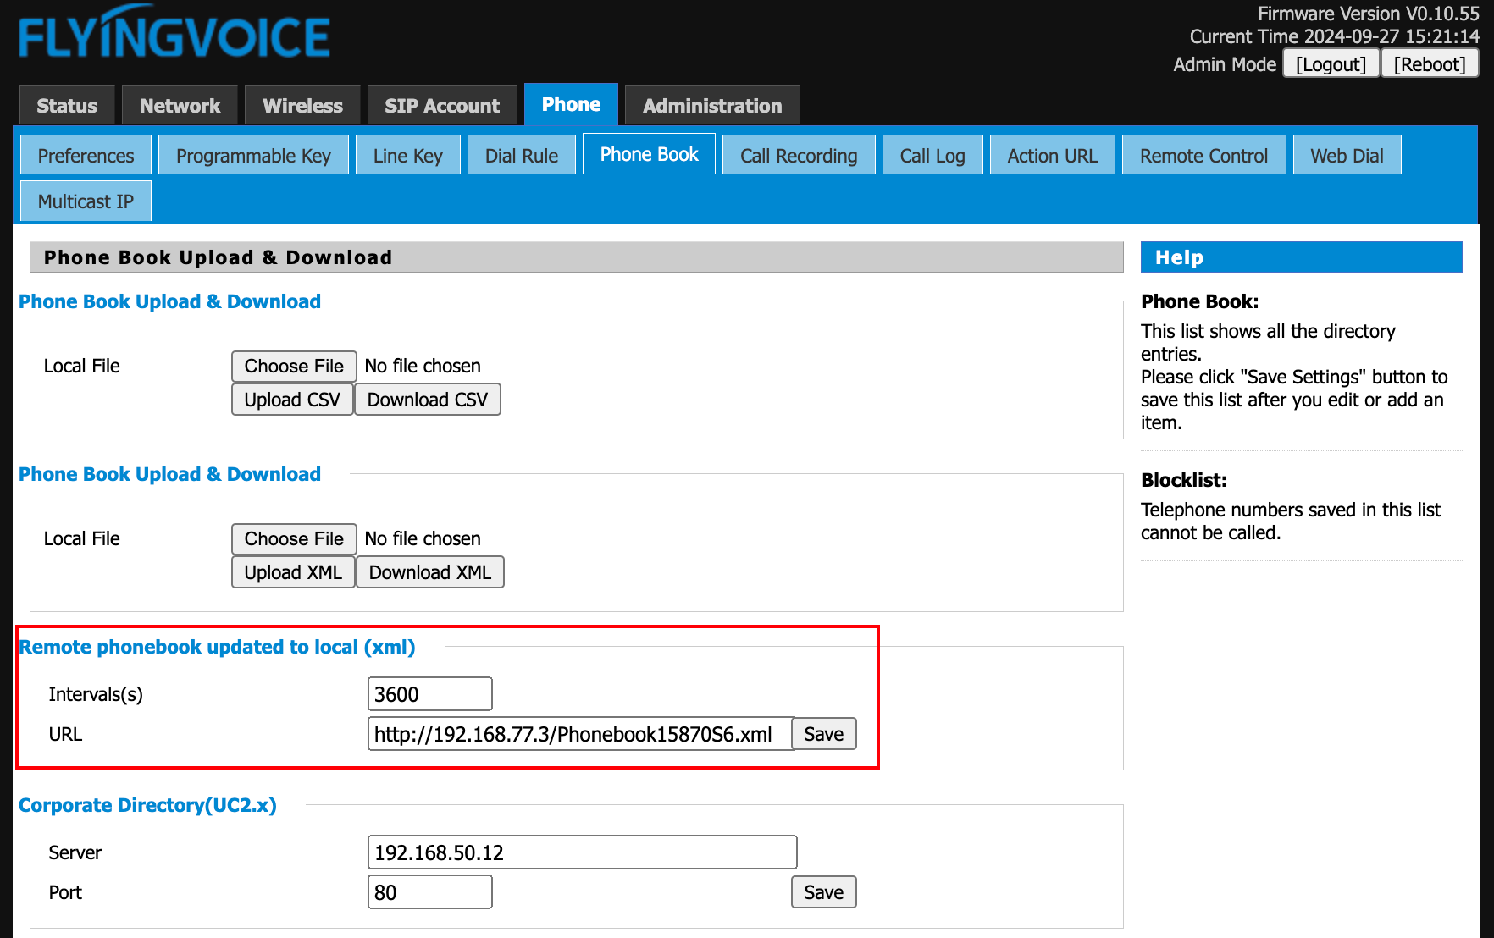

Example of xml file (http server):

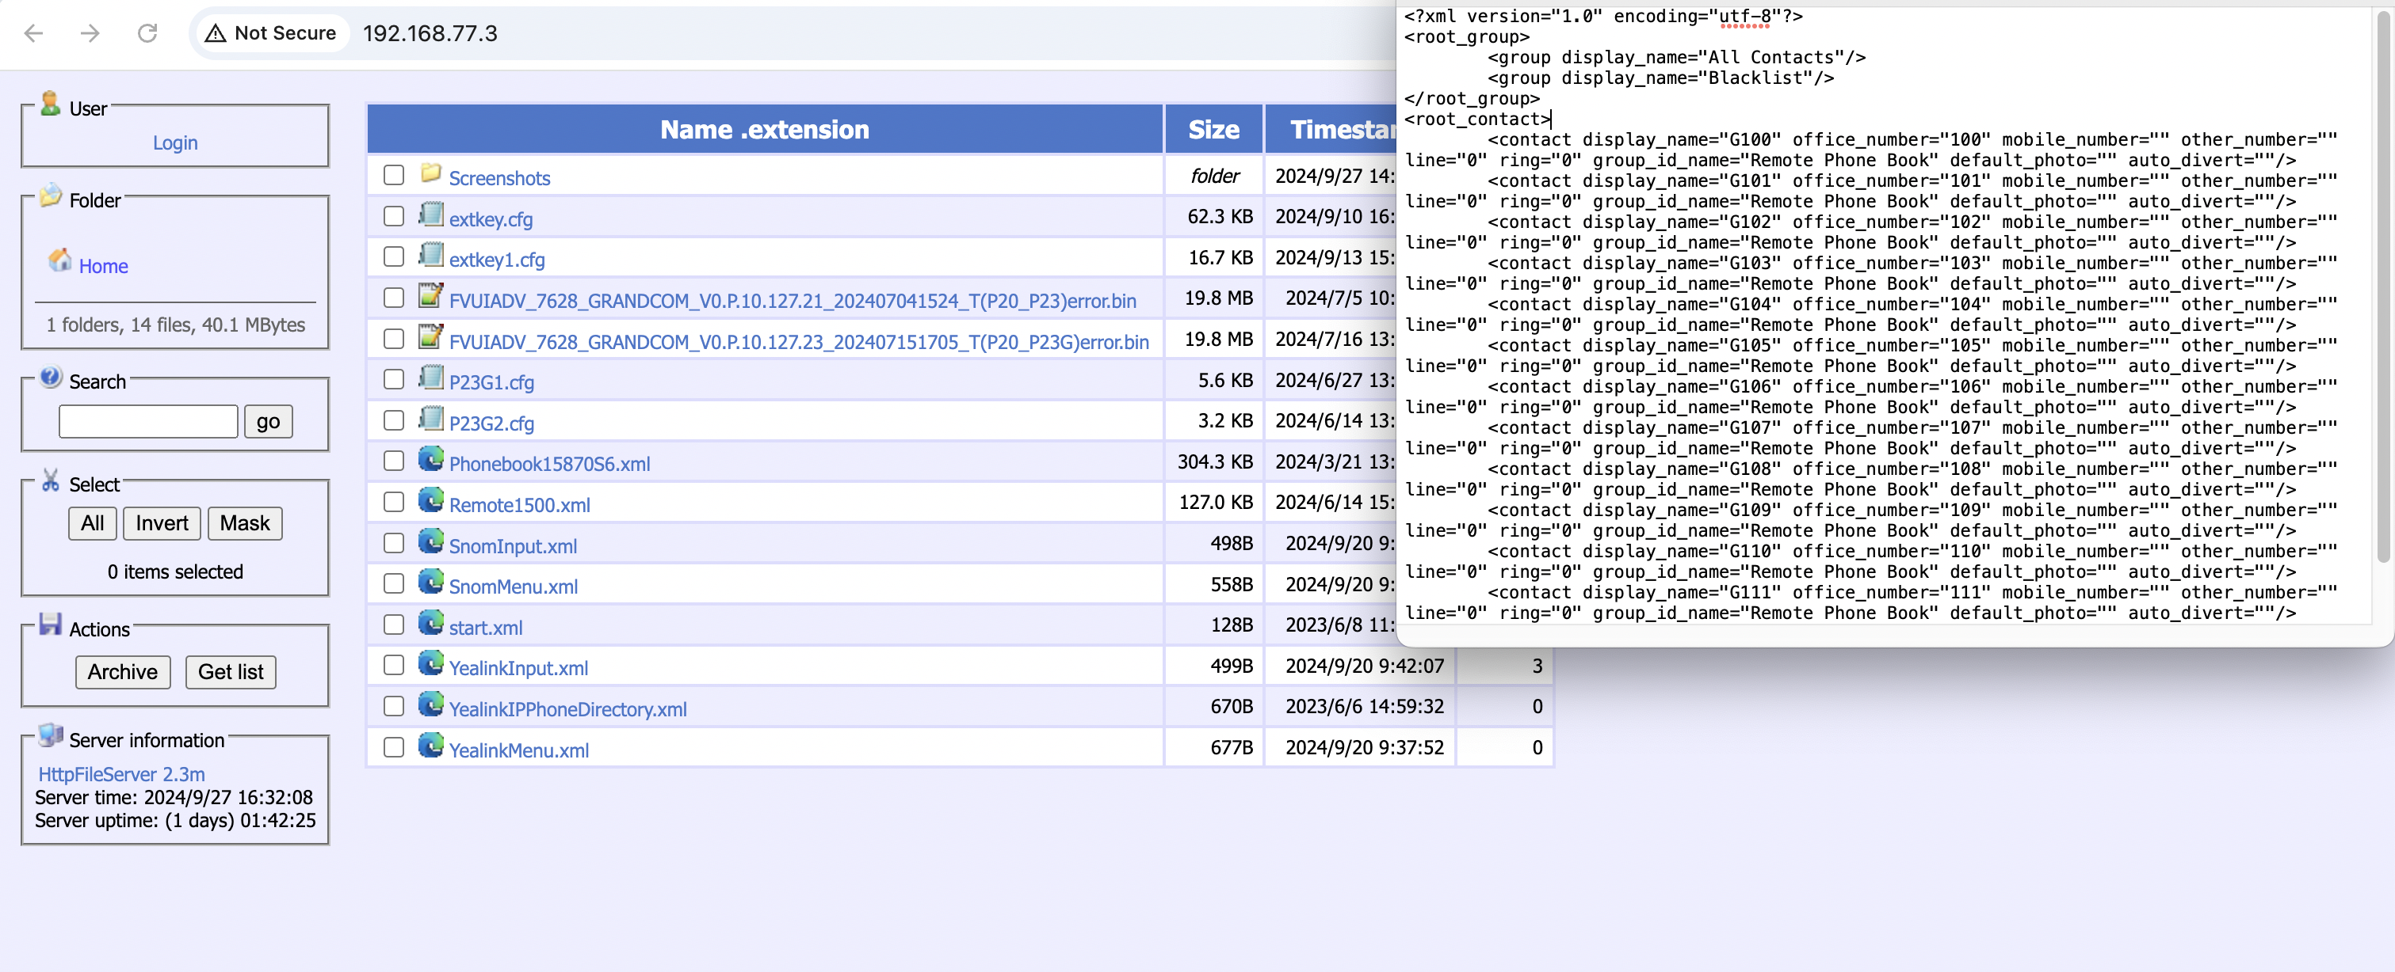

You can view the Phonebook (All Contacts) on the web:

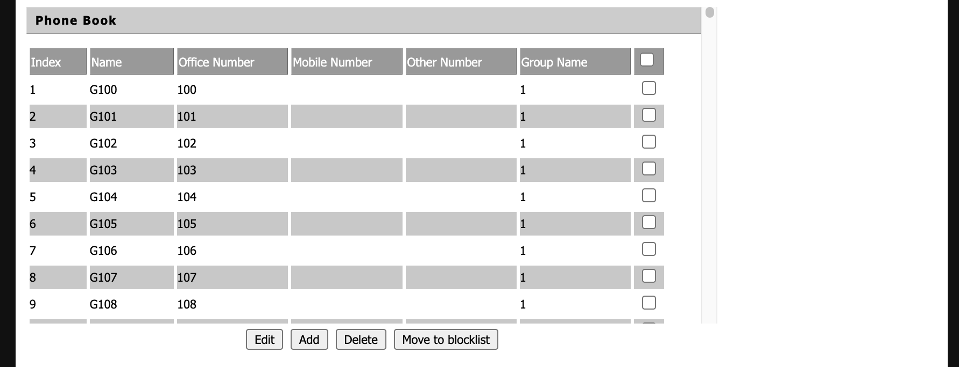

**View Remote phonebook (All Contacts) through the phone screen:**

1. Click **Menu**->**Directory**->**Local Contacts**, you can see the imported phonebook.

2. View the list of contacts in the phonebook

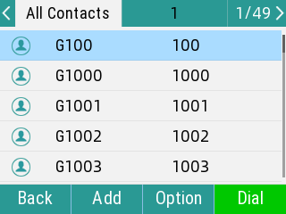

### Remote Phonebook

You can access the Remote Phone Book remotely and see the complete organization contact information. you can configure up to 4 URLs.

**Procedure**

Configure the Remote Phone Book via the Web UI:

1. Go to the web UI and click **Phone** -> **Phonebook** -> **Remote Phonebook** **Download** **(xml**)

2. In URL, fill in the **URL** address and Phonebook name (directory name), optional Incoming/Outgoing Call Lookup

3. Click **Save**

TIPS: You can fill in more than one remote phonebook URL.

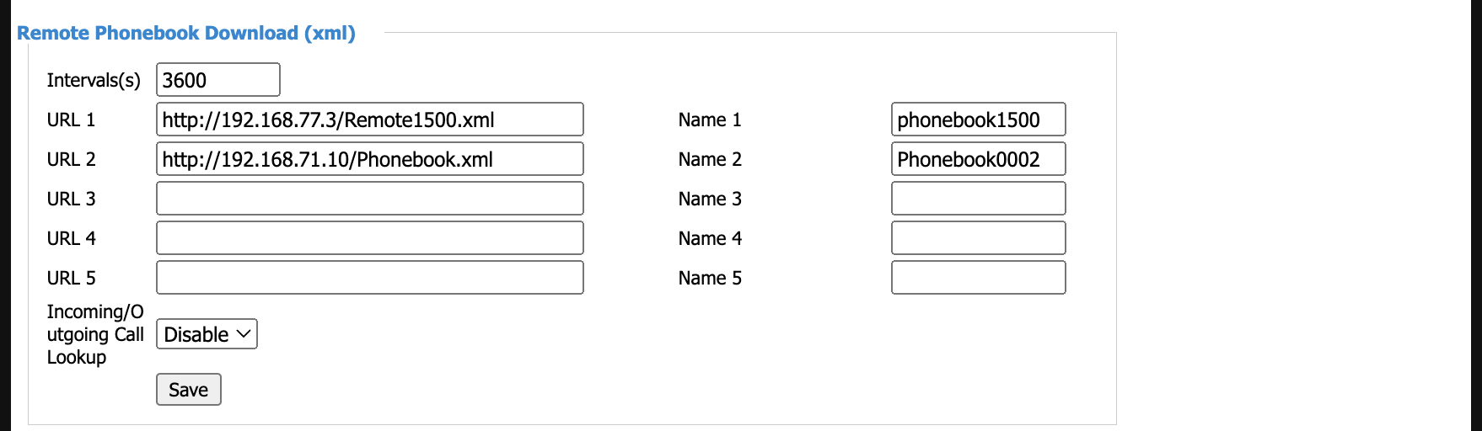

**To view the remote phone book through the phone screen:**

1. Click **Menu**->Remote Phone Book->Remote Address Book and select the imported remote group.

2. View the list of contacts in the **Remote Phone book**.

**TIPS:** You can Dial/Search/Add Contacts.

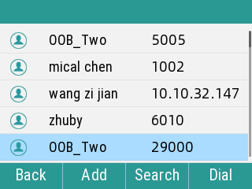

## 4.8 LDAP

LDAP stands for Lightweight Directory Access Protocol, which is a client-server protocol for accessing a directory service.LDAP directory feature of the Flyingvoice phone allows you to search for contacts.

**Configure LDAP Address Book through the web interface:**

1. Click **Phone**-> **Phonebook**->**LDAP**, select **Enable** LDAP

2. Fill in the server address information of Corporate address book, as shown below.

3. Click **Save.**

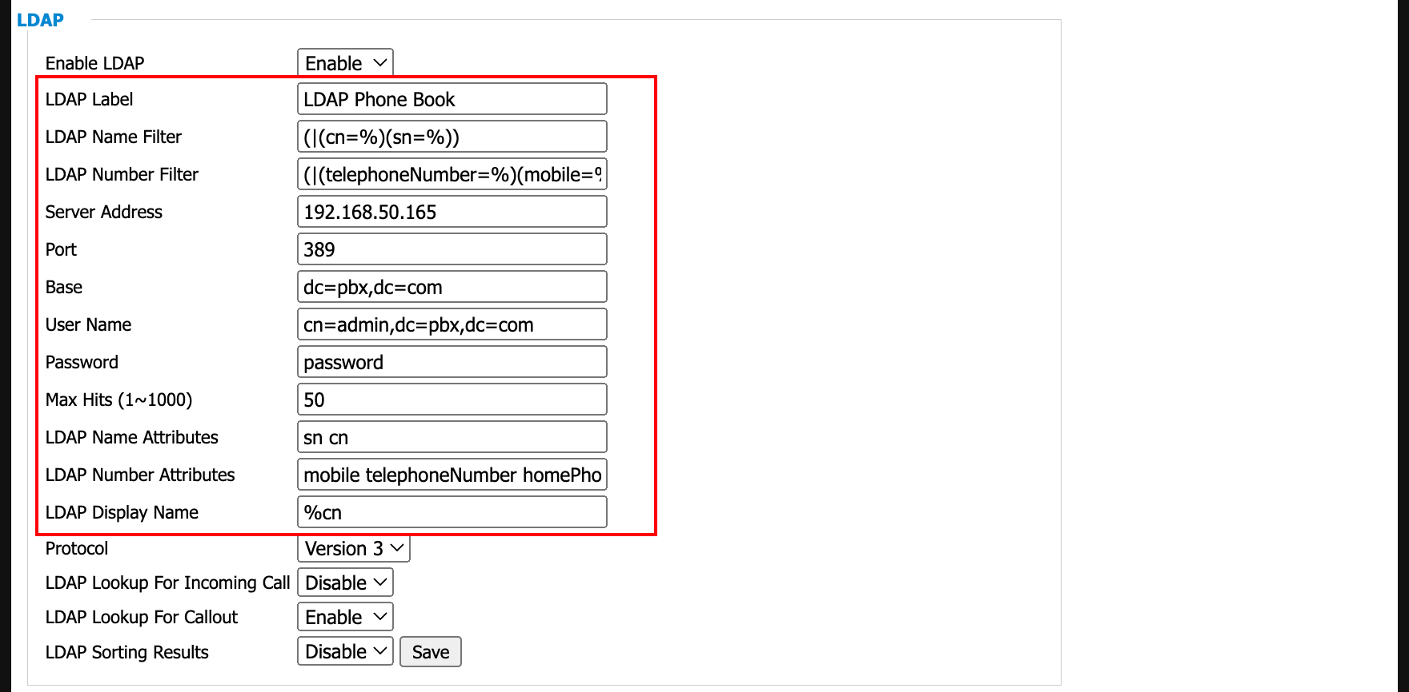

**Example (Labeling selection depends on the server):**

Enable LDAP: Enable/Disble

LDAP Label: LDAP Phone Book（Display Name）

LDAP Name Filter: (|(cn=%)(sn=%))

LDAP Number Filter: (|(telephoneNumber=%)(homePhone=%)(mobile=%))

LDAP Server Address: 192.168.20.165

Port: 389

Base: dc=pbx,dc=com

User Name: cn=admin,dc=pbx,dc=com

Password: password

Max Hits (1~1000) : 50

LDAP Name Attributes: cn sn displayName

LDAP Number Attributes: telephoneNumber homePhone mobile mail departmentNumber

LDAP Display Name: %cn

Protocol: Version 3

LDAP Lookup For Incoming Call: Enable

LDAP Lookup For Callout: Enable

LDAP Sorting Results: Enable

**Add to Contact/Blocklist through LDAP Phone Book:**

1. On the Phone UI, go to **Menu**-> **Directory**, select your **LDAP**.

2. Select a number, press **Option**->**Add to Contact/Blocklist**, you can view the **Detail** of a contact or **Dial**.

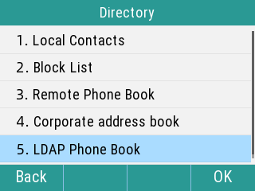 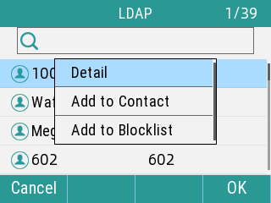

**Search Contacts through LDAP Phone Book:**

1. On the Phone UI, go to **Menu**-> **Directory**, select your **LDAP**.

2. Enter the **keywords** for the contact and the screen will display the search results.

## 4.9 Call History

The call history list includes Missed Calls, Dailled Calls, Received Calls, and each list holds 60 entries.

**Topics**

Viewing History Records

Saving a History Record to Local Directory

Saving a History Record to Blacklist

Deleting History Records

### Viewing History Records

The history record saves the call information such as the caller's name and number, local line and call duration.

**Procedure**

1. Press **History**.

2. Select the desired list.

3. Select the desired entry.

4. Select **Option** > **Detail**.

### Saving a History Record to Local Directory

To identify someone's call the next time, you can save a history record to the Local Directory.

**Procedure**

1. Select **History**.

2. Select the desired list.

3. Select the desired entry, and select **Option** > **Add to Contacts**.

4. Edit the contact information.

5. Select **OK**.

### Saving a History Record to Blacklist

You can prevent someone from calling you again by saving a history record to Blacklist.

**Procedure**

1. Select **History**.

2. Select the desired list.

3. Select the desired entry, and select **Option** > **Add to Blacklist**.

4. Edit the contact information.

5. Select **OK**.

### Deleting History Records

You can delete one or all call records from the call history list.

**Topics**

Deleting a Call Record

Deleting All Call Records

#### Deleting a Call Record

You can delete any call record from the call history list.

**Procedure**

1. Press **History**.

2. Select the desired list.

3. Select the desired entry, and select **Delete**.

#### Deleting All Call Records

You can delete all call records from the call history list.

**Procedure**

1. Press **History**.

2. Select the desired list.

3. Select the desired entry, and select **Delete All**.

*The phone prompts you whether to delete all the records.*

1. Select **OK**.

## 4.10 Hot desking

In office scenario, the Hot desking feature allows you to quickly clear all of your phone's current SIP accounts and register new accounts easily and efficiently.

**Topic**

Configure Hot desking

Use Hot desking

### Configure Hot desking

Configure the function via the phone web page.

**Procedure**

1. **Phone**->**Line** **Key**->Select Line Key x, type set to **Hot desking**

2. **Save**

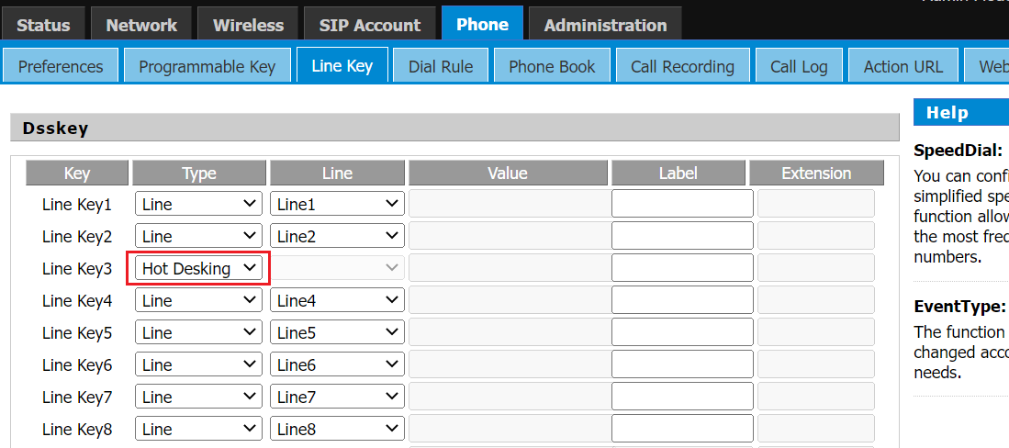

### Use Hot desking

**Procedure**

1. In the phone, press **Hot desking**
2. Select "OK" or "Cancel" when prompted?

If you press **OK**, all SIP will be cleared; if you **cancel**, you will return to the home.

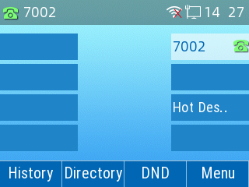 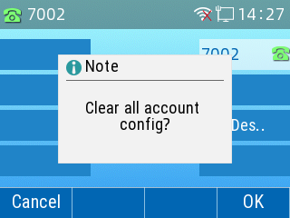

3. After the SIP settings are clear, automatically jump to fill in the interface, you can choose to **Back**, there is no account information at this time; you can also enter a new account number to complete the registration.

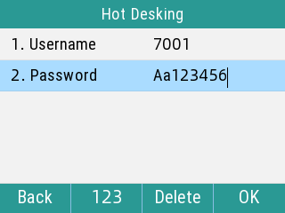 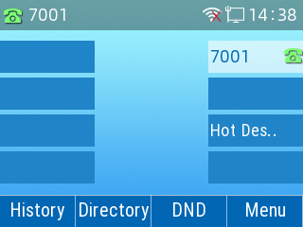

**Tip:** The registered new account is Account 1 by default.

## 4.11 Beeper

P2X series phones support HB01 wireless emergency button and PB01 USB Panic Button, the following is the function configuration introduction

**Topic**

### HB01 Call Button

**Pairing through the phone UI**

1. On the Phone UI，Go to **Menu**> **Features**> **Beeper** > **Beeper pairing list**
2. Press **Search**，the phone will enter the pairing mode, and searching icon加载 will appear on the top.
3. Press the HB01 button that needs to be paired, the phone UI will show device ID, press Pair, and it will prompt "Pairing the Beeper", and phone UI will show the icon of successful connection成功.
4. If you want to pair more buttons, repeat **Step 3**.

**TIPS：**The search mode will be turned on for 60s, if no new device is connected, it will be turned off automatically after the time limit.

**Configure SpeedDial through the phone UI**

1. Long press **M1 Key** of the phone, enter the interface of Configuration.

2. Select **SpeedDial** type, select **Line**, type in SpeedDial Number.

3. Press **Save**.

**TIPS**: The corresponding physical phone key for this function is the M1 key.

### PB01 USB Panic Button

**Settings through the phone UI**

1. On the Phone UI, Go to **Menu**> **Features**>**Beeper**>**Emergency button speed dial settings**

2. Enter the emergency speed dialing interface and select the mode of the USB button (Disabled, Silent, SpeedDial)

3. Select **Silent Mode** and fill in the **value** for the Emergency number.

4. Click **Save** Settings.

**TIPS:** When the mode is Disable, the USB switch will not take action when pressed; when the mode is Silent, there will be no sound during the whole process of dialing out and answering; when the mode is SpeedDial, it will be the normal speed dialing of the call.

# Chapter 5 Customizing Your Phone

You can make your phone more personalized by customizing various settings.

**Topics**

Basic Setting

Audio Settings

AP Mode

## 5.1 Basic Setting

**Topics**

Backlight

Language

Time & Date

Changing the Administrator Password

Call Immediately key

Phone lock

### Backlight

You can change the brightness of the phone screen during phone activity and inactivity. The brightness automatically changes after the phone has been idle for a specified time.

You can change the screen backlight and time in the following settings:

**Backlight Time:** The delay time to change the brightness of the phone screen when the phone is inactive. Backlight time includes the following settings:

* **Always On:** Backlight is on permanently.
* **15s, 30s, 1min, 2min, 5min, 10min or 30min:** Backlight is changed when the phone is inactive after the designated time.

**Activel Level:**

The current screen brightness level.

**Inactive Level:**

Brightness level in standby.

**Procedure**

1. Navigate to **Menu** > **Basic** > **Display** > **Backlight Time**.

2. Select the desired time from the **Backlight Time** field.

3. Select **Save**.

### Language

Your phone supports several languages that you can choose to use on the phone.

Contact your system administrator to find out exactly which languages are supported on your phone.

**Procedure**

1. Navigate to **Menu** > **Basic** > **Language**.

2. Select the desired language.

3. Select **OK**.

*The phone language is changed to the selected one.*

### Time & Date

You can set the time and date manually. The time and date formats are also variable.

**Topics**

Setting the Time and Date Manually

Changing the Time and Date Format

#### Setting the Time and Date Manually

If your phone cannot obtain the time and date automatically, you can set it manually.

**Procedure**

1. Navigate to **Menu** > **Basic** > **Time & Date** > **General**.

2. Select the Manual from the General field.

3. Edit the date and time.

4. Select **OK**.

*The time and date set on the phone will be changed accordingly.*

#### Changing the Time and Date Format

You can set the phone to display the time in 12-hour format or 24-hour format.

**Procedure**

1. Navigate to **Menu** > **Basic**> **Time & Date** > **Time Format**.

2. Select the desired time format.

3. Select **OK**.

### Changing the Administrator Password

By default, you need input administrator password to access the **Advanced** setting menu. The default password is “admin”. For security reasons, you should change the default password as soon as possible.

**Procedure**

1. Navigate to **Menu** > **Advanced** > **Change Password**.

2. Select **Menu Password** Enter your old and new password information.

3. Select **OK**.

### Call Immediately key

You can set the "#" key or the "*" key as the call Immediately key, the default is the "#" key

Setting via phone web

**Procedure**

1. **Phone**-> **Preferences**-> **Miscellaneous**
2. Select "#" or "*", click **save and apply**

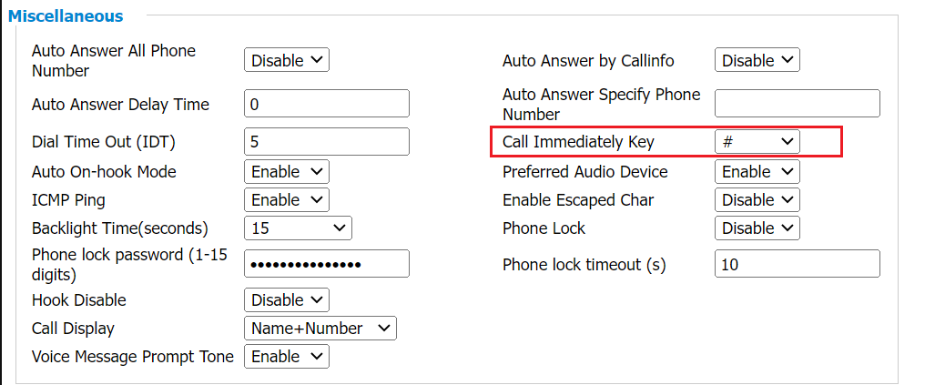

### Phone lock

To set the keypad lock locally via the phone.

1. Press **Menu**->**Basic Settings**->**Phone Lock**

2. Select the Phone Lock on or off by press **Switch**

3. fill in the **keyboard lock time** (unit: seconds)

4. Click **Set Password**, fill in the new password, confirm again and press **OK**

**Tip：**If the two password input is same, it will prompt "password change successfully", else it will prompt "two password input inconsistent", you need to input password again

1. After successful setting, the LCD will be locked after the screen is turned off, click the **Unlock**, enter password and click **OK** to unlock the screen.

## 5.2 Audio Settings

You can change the basic audio settings on your phone.

**Topics**

Adjusting the Volume

Setting the Ring Tone

### Adjusting the Volume

You can adjust the volume of the ringer, media, and the audio during a call.

**Procedure**

1. Press the **Volume** key to adjust the volume.

### Setting the Ring Tone

You can set distinctive ring tones for groups or contacts in your Local Directory so that you can identify the caller when your phone rings.

The ring tones are used according to this priority: Contact ring tone>Group ring tone>Account ring tone >Phone ring tone.

**Topics**

Setting a Ring Tone for the Phone

Setting a Ring Tone for a Group

Setting a Ring Tone for a Contact

#### Setting a Ring Tone for the Phone

You can choose a ring tone for all incoming calls.

**Procedure**

1. Navigate to **Menu** > **Basic**> **Ring** >**Ring Type**.

2. Select the desired ring tone.

3. Select **OK**.

#### Setting a Ring Tone for a Group

You can select a unique ring tone for various groups in your Local Directory.

**Tip：**You can only set a ring tone for a group that is added manually.

**Procedure**

1. Select **Directory** or navigate to **Menu** > **Directory**> **Local Contacts**.

2. Select the desired group.

3. Select **Option** > **Detail**.

4. Select the desired ring tone from the **Ring Type** field.

*If a specific ring tone is selected, this group uses the ring tone according to the priority: Contact ring tone>Group ring tone.*

5. Select **Save**.

#### Setting a Ring Tone for a Contact

You can select a unique ring tone for various contacts in your Local Directory. This helps you quickly identify callers according to the ring tones.

**Procedure**

1. Select **Directory** or navigate to **Menu** > **Directory**> **Local Contacts**.

2. Select the desired contact group or **All Contacts**.

3. Choose the desired contact, and select **Option** > **Detail**.

4. Select the desired ring tone from the **Ring Type** field.

5. Select **Save**.

## 5.3 AP Mode

You can use the FLYINGVOICE Phone as an AP wireless access point, and you can use wireless devices (mobile wireless devices such as cell phones and computers) for network connection.

### Enable AP Mode

AP mode, when turned on, shuts down the phone's connection to Wi-Fi.

**Procedure**

1. Press the **Menu**->**Advanced**->**Network**->**AP**

2. Select AP **ON**, enter the SSID and Password, select **Security** and **Encryption Mode**

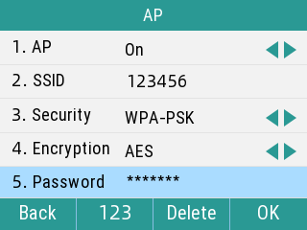

3. Press **Save**

4. Phone UI will prompt "Turing on AP mode will turn off Wi-Fi. Do you want to reboot?", Press **OK**

5. Wait for the phone to restart, you can find the AP access point in your Wi-Fi list.

**Configure the AP Mode via the web interface:**

1. Enter the phone's web interface, navigate to **Wireless** -> **Wireless Hotspot**.

2. Select **AP Switch** - select **Enable**.

3. The device will generate a default wireless network name (SSID). Enter the wireless hotspot password.

4. Click Save. The phone's AP mode will take effect after restarting.

TIPS: If the security mode is set to None, there is no need to enter a wireless hotspot password, and the Wi-Fi will be an open network.

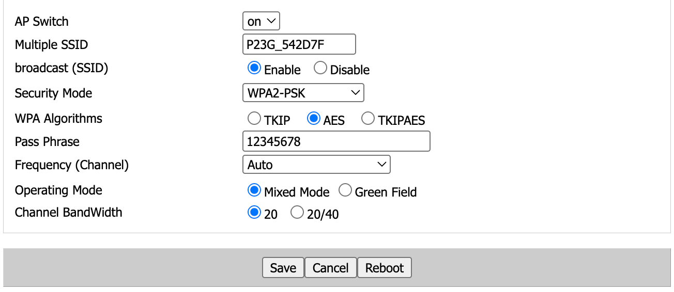

# Chapter 6 Maintaining Your Phone

When your phone is unable to operate properly, you need to investigate or troubleshoot issues along with other tasks your system administrator may ask you to perform.

**Topics**

Rebooting Your Phone

Resetting to Factory Settings

## 6.1 Rebooting Your Phone

The improper operation may cause malfunction. If the malfunction occurs, your system administrator may ask you to reboot your phone.

**Procedure**

1. Navigate to **Menu** > **Basic** > **Reboot**.

*The phone prompts you whether to reboot the phone.*

2. Select **OK**.

**Tip:** You can also long press the Cancel key on the keypad when the phone is idle to reboot the phone.

## 6.2 Resetting to Factory Settings

When some issues occur on your phone and you have tried all troubleshooting suggestions but still do not solve the problem, you can reset your phone to factory configurations.

This operation will delete all your personal configuration settings, and reset all settings to the factory defaults. Check with your system administrator if the personalized settings are kept before resetting your phone to factory settings.

**Procedure**

1. Navigate to **Menu** > **Advanced** (default password: admin) > **Reset to Factory Settings**.

2. Select **Reset to Factory Settings**.

*The phone prompts you whether to reset the setting.*

3. Select **OK**.

*The phone begins resetting.*

**Tip:** Reset of your phone may take a few minutes. Do not power off until the phone has started up successfully.